VTB Controller User Modification Manual

I.Function Overview
1.Structural Design
—Supports CNC water-cooling radiators
—CNC air cooled heatsink option
—Ingress protection IP67 rated
—High-reliability redundant design
—High-voltage short-circuit protection for harnesses
—Intelligent battery protection system
—Fully potted vibration-resistant protection
—Sine wave vector control
2.Specifications and Parameters
—Maximum bus current: 500A
—Maximum phase current: 960A
—Peak output power: 44kW
—Operating temperature range: -25℃ to 80℃
—Absolute voltage range: 30V to 99V
—Operating voltage range: 48V to 84V
—Maximum efficiency: >95%
3.Compatible Models
—Sur-Ron Light Bee
—Sur-Ron Ultra Bee
—TALARIA Sting
—TALARIA X3
—79BIKE Falcon
—E-Ride Pro SS
4.Compatible Motors
—VTB Beast 28kW
—VTB Beast 35kW
—Stock Light Bee Motor
—Stock Ultra Bee Motor
—Stock Sting 8.0 Motor
—Stock E-Ride Motor
—QS165 Motor by QS Motor
—EBMX XLB-60 Motor
—EBMX XUB-80 Motor
—SOTION LTXS Motor
—KO Encoder Motor
5.Compatible Batteries
—20S | VTB7245-9C 72V 45Ah Samsung 50S
—20S | VTB7250-9C 72V 50Ah Samsung 50S
—20S | VTB7250-5C 72V 50Ah Samsung 50G
—20S | Stock Ultra Bee 74V 55Ah Farasis P53B
—20S | Stock E-Ride Pro SS 72V 40Ah Samsung 50G
—16S | Stock Light Bee / Sting 8.0 60V 38.5Ah Samsung/LG
—16S | Stock Light Bee / Sting 8.0 60V 40Ah Samsung/LG
—16S | Stock Talaria X3 60V 38.5Ah LG
—20S | EBMX/EWATT 72V 42Ah
—20S | EBMX/EWATT 72V 57Ah
—20S | EWATT 72V 76Ah
—22S | EWATT 80.3V 76Ah
—20S | EWATT 72V 44Ah
—22S | 8045 80V 45Ah
—18S | 6642 66V 42Ah
—17S | 6355 63V 55Ah
—16S | 6055 60V 55Ah
—16S | 6045 60V 45Ah
6.App Introduction
—Free download across multiple platforms
—Throttle fine-tuning
—Low battery throttling and power auto-tuning
—Multiple separate programmable power settings
—EBS gear adjustment
—E-assist brake
—keyless entry
—Motor calibration
—Power-Off Protection (Brake, Tilt, Stand)
—Bluetooth password
—Speed calibration

II. Preparations Before Installation
1.Installation Instructions
The V9600 controller is currently designed to operate in conjunction with the VTBGZ display, multi-functional combination switch, and regen brake （thumb brake）. These components are packaged together with the controller for convenience. The installation of the accompanying components is straightforward, allowing users to complete the setup independently. It is recommended, however, that users refer to the contents of this manual for guidance during the installation process. The V9600 is a plug-and-play controller, requiring no prior knowledge of electronics or programming for installation and configuration.
2.Packing List
①V9600 Controller×1
②Display×1
③Switch Assembly×1
④Throttle Grip (including left-hand rubber sleeve)×1
⑤Regen Brake（thumb brake）×1
⑥Display Mount (with installation screws)×1
⑦Mid-section Wiring Harness×1
⑧Dust-proof Rubber Covers for Terminals×5
⑨Terminal Screws×5
⑩V9600 Installation Manual×1
⑪Compatible Vehicle Accessory Kit×1
—Accessory Kit Contents—
The accessories are arranged from left to right as shown in the illustration:
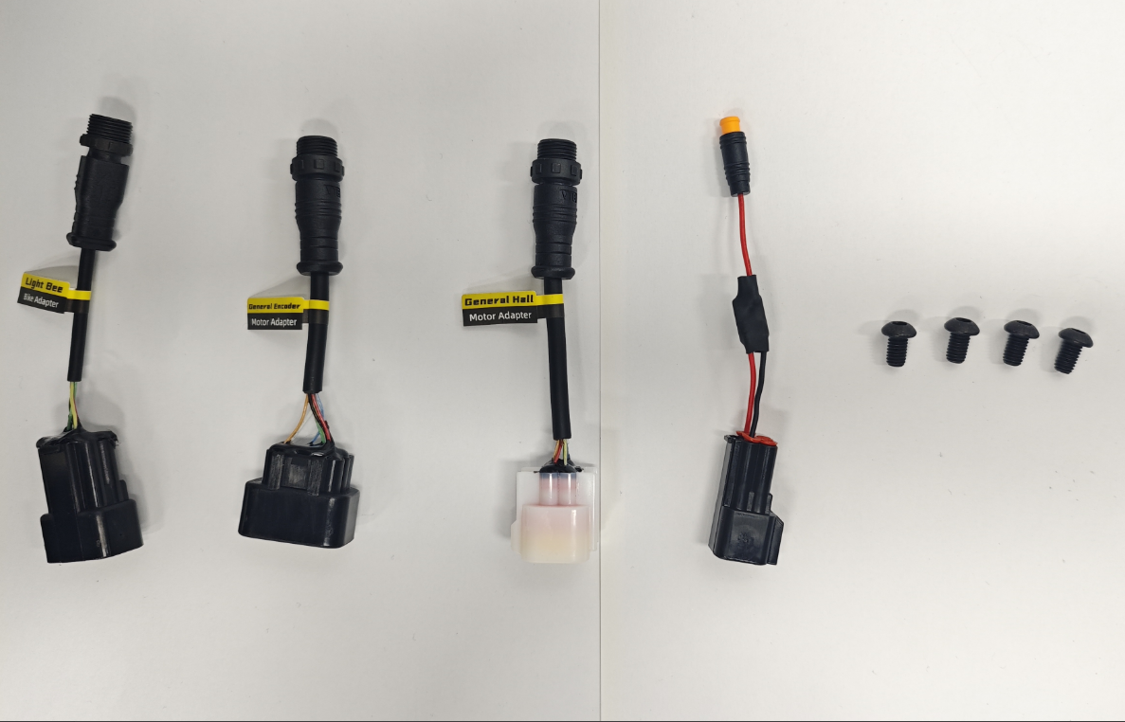
Light Bee Bike Adapter×1: Connects to the main vehicle harness
General Encoder Adapter×1: Connects to the motor encoder harness
General Hall Adapter×1: Connects to the motor Hall harness (for Hall-effect motors)
Horn Driver×1: Connects the main vehicle harness to the mid-section wiring harness
M6*10 Round-Head Screws×4: Secures the V9600 Controller
3.Route Description
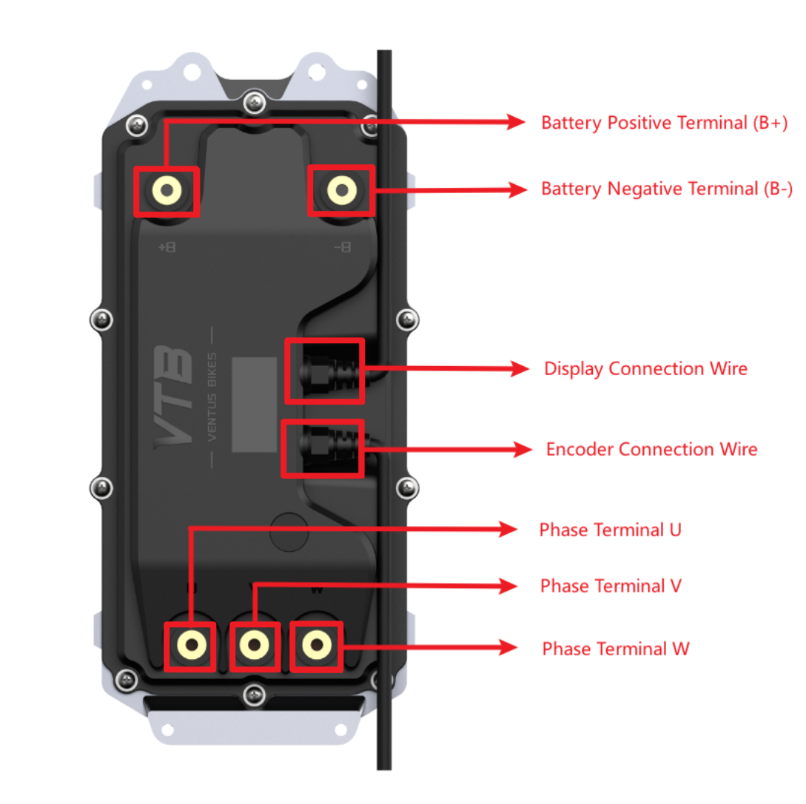
Special Note: The V9600 controller is equipped with a motor calibration, allowing the phase connection sequence to be unrestricted and freely arranged. The designations of U, V, and W in this context are merely illustrative labels. This innovative feature is intended to accommodate various motor types, ensuring the system can automatically adjust phase sequences based on the connected motor to achieve optimal performance.
4.Installation Hole Diagram
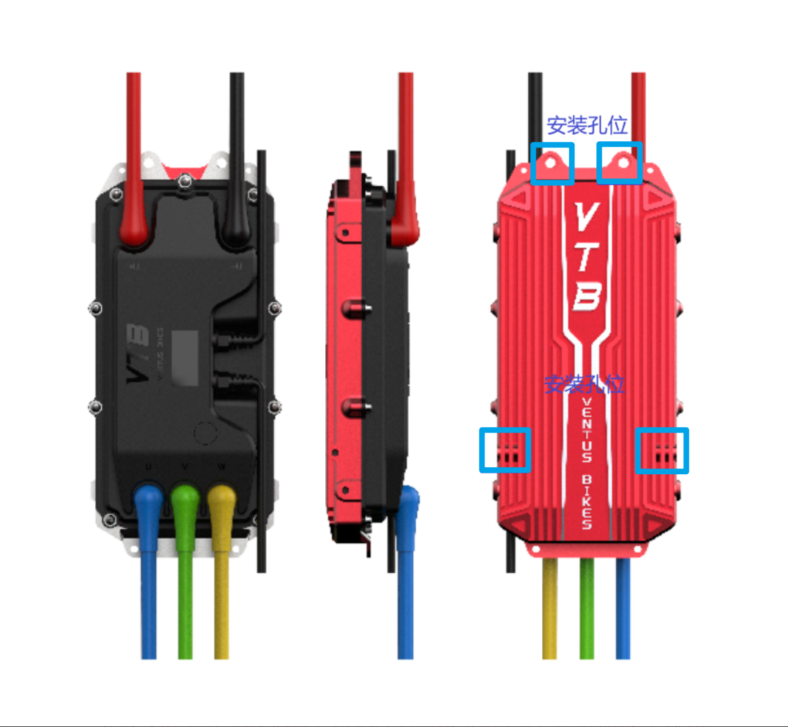
The installation holes for the Light Bee are indicated by the four positions outlined in the rectangular frame in the diagram.

III. Installation and Precautions
1.Connecting Motor Phase Wires
Note: Before proceeding with the installation of the controller, ensure that the circuit breaker is completely turned off. Inspect the power lines connected to both sides of the circuit breaker to confirm they are securely fastened. If any wires are found to be loose, tighten the corresponding cross-head screws on the circuit breaker.
Connect the motor phase wires to the phase terminals. It is not necessary to differentiate between cable colors, as the connection sequence is unrestricted. While the phase wire lengths may vary, great care must be taken to avoid entanglement during the connection process. Use a wrench to apply a torque of 16 N·m to securely fasten the terminal screws, ensuring all connections are robust to prevent potential loosening during operation. Once all the phase wires are correctly and securely connected, cover the connection points with dust-proof rubber covers.
Important Note: The V9600 controller is equipped with a motor calibration feature, allowing the phase wire connection sequence to remain flexible. Connections should therefore be arranged according to the actual length of the wiring harness for ease of installation and organization.
2. Connecting the Positive and Negative Power Terminals
Connect the power lines following the sequence: red for the positive terminal and black for the negative terminal. To facilitate subsequent installation, slightly adjust the angles of the positive and negative power lines outward. Ensure that every connection point is securely fastened to prevent loosening during operation. Once the positive and negative power lines are properly fixed, cover the connection points with dust-proof rubber covers for protection.
The final appearance after completing the installation of both the motor phase wires and the positive and negative power lines is shown in the diagram below:
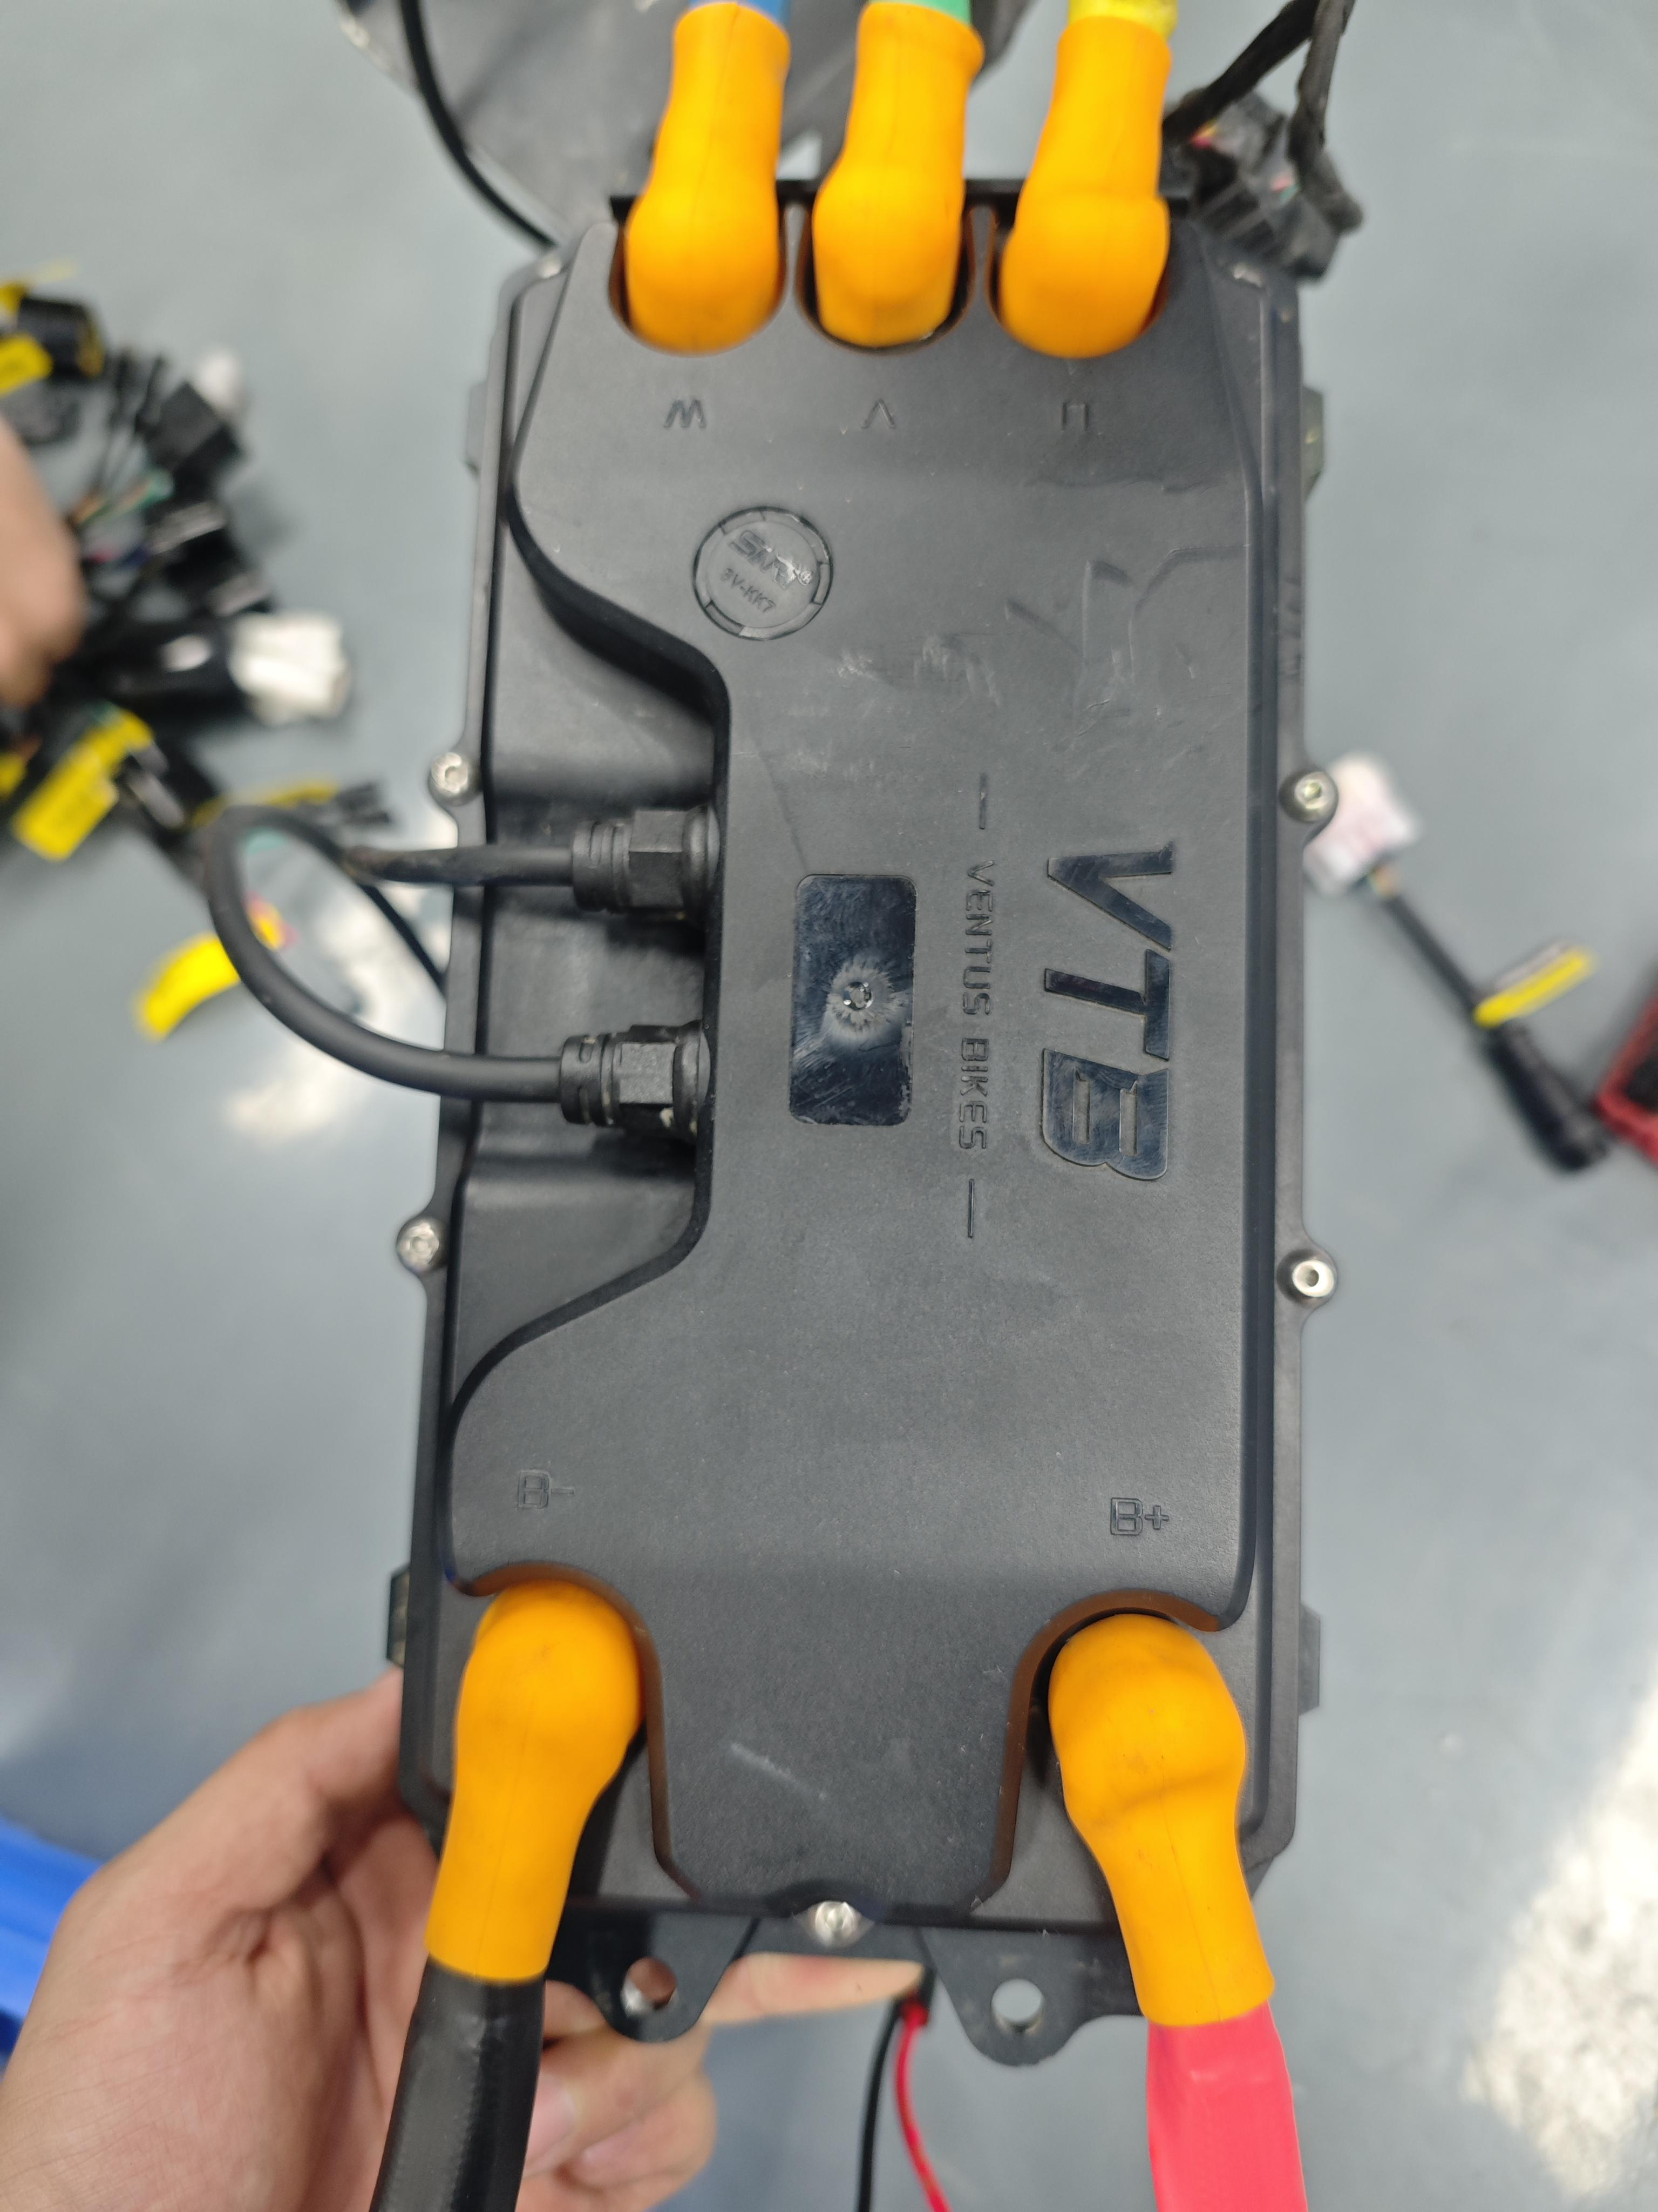
3. Connecting the Motor Plug
For the stock Light Bee motor and third-party Hall motors, a general Hall motor adapter is required.For third-party encoder motors, a general encoder motor adapter is needed (note: the label is missing in the bottom-center diagram and requires retaking). One end of the motor adapter connects to the motor harness interface, while the other end connects to the shorter harness of the controller (as shown in the bottom-right diagram). The stock VTB motor does not require the use of a motor adapter.
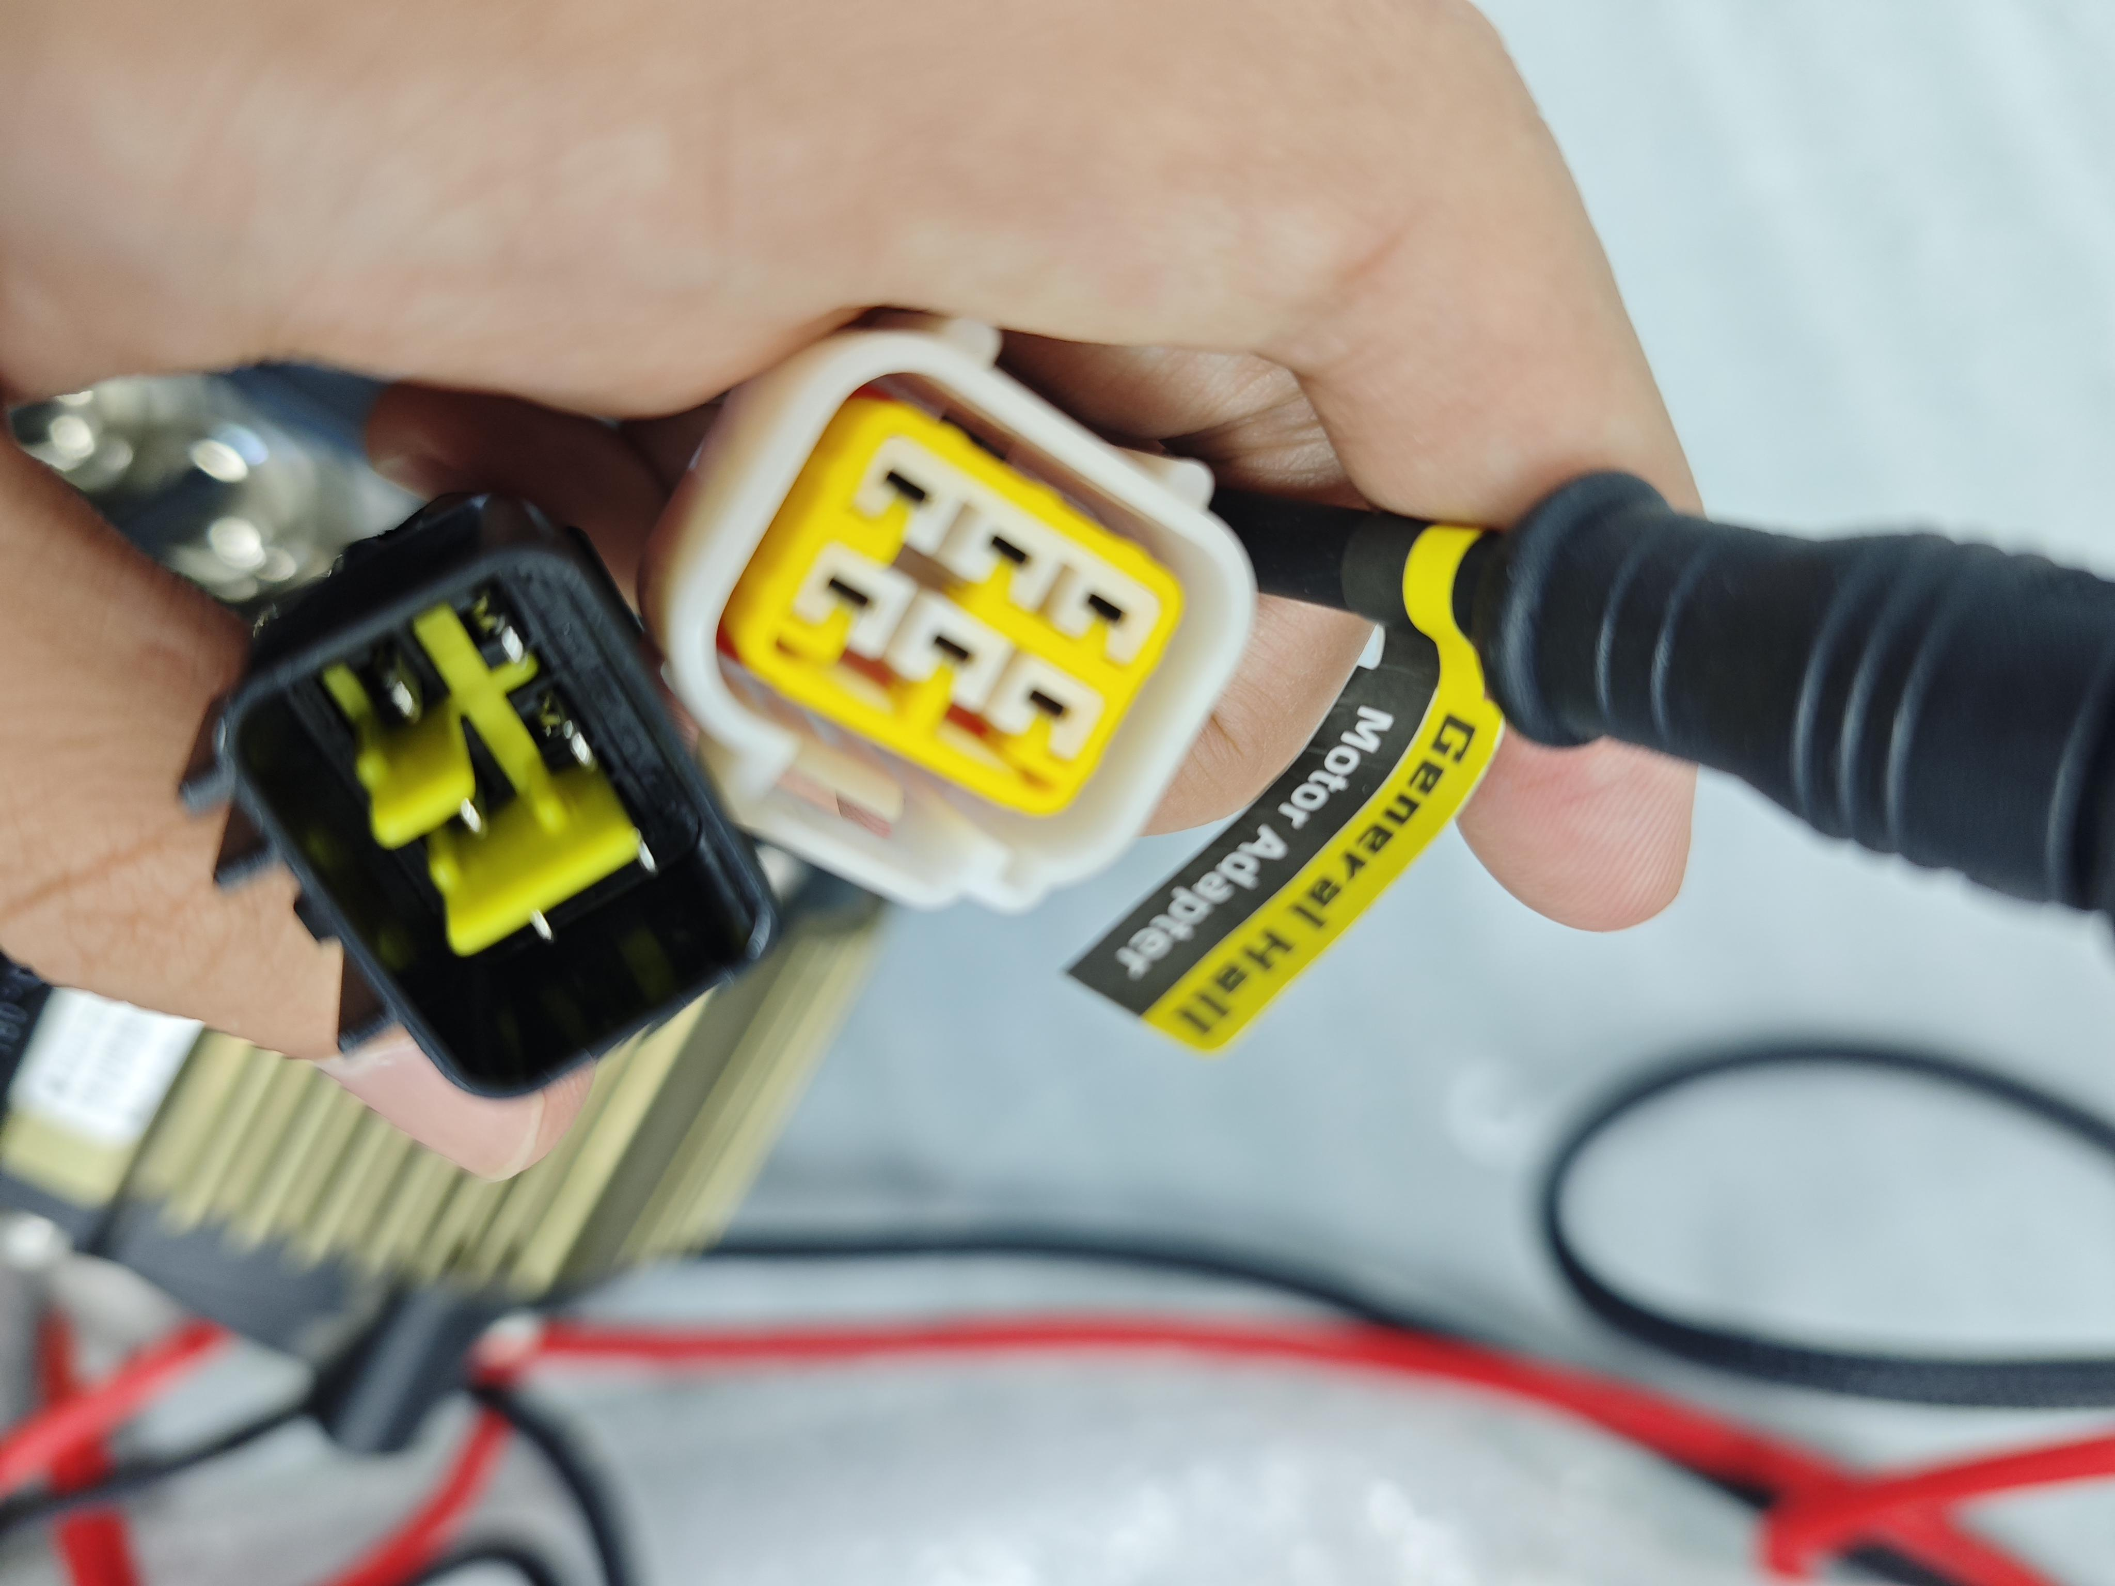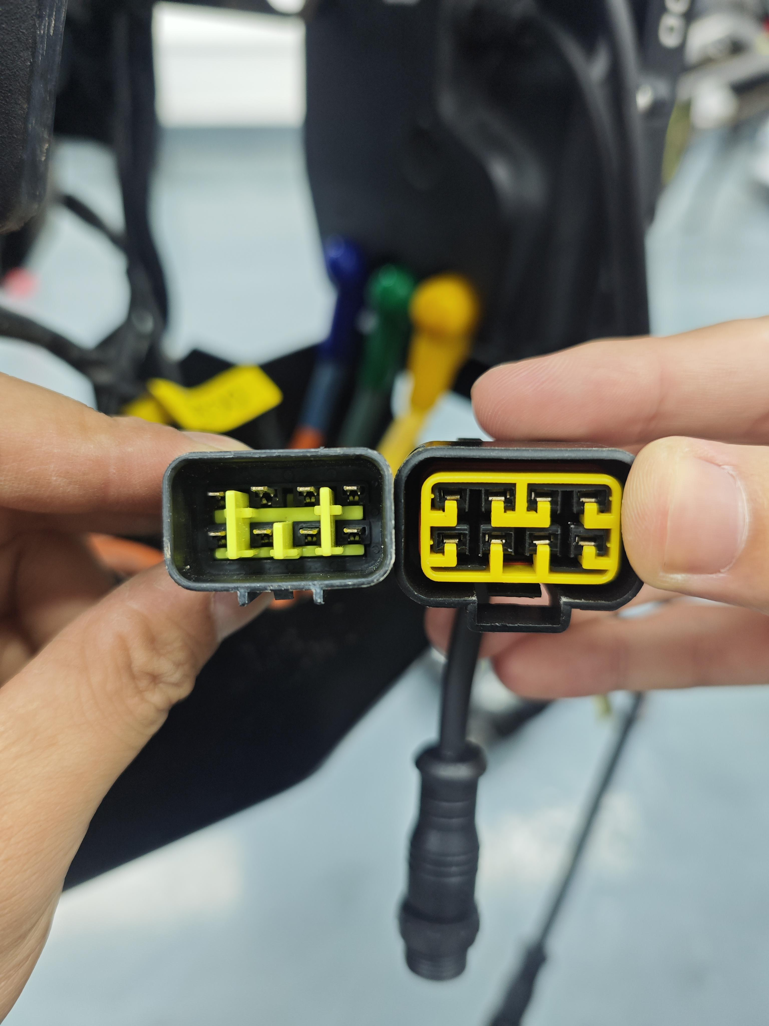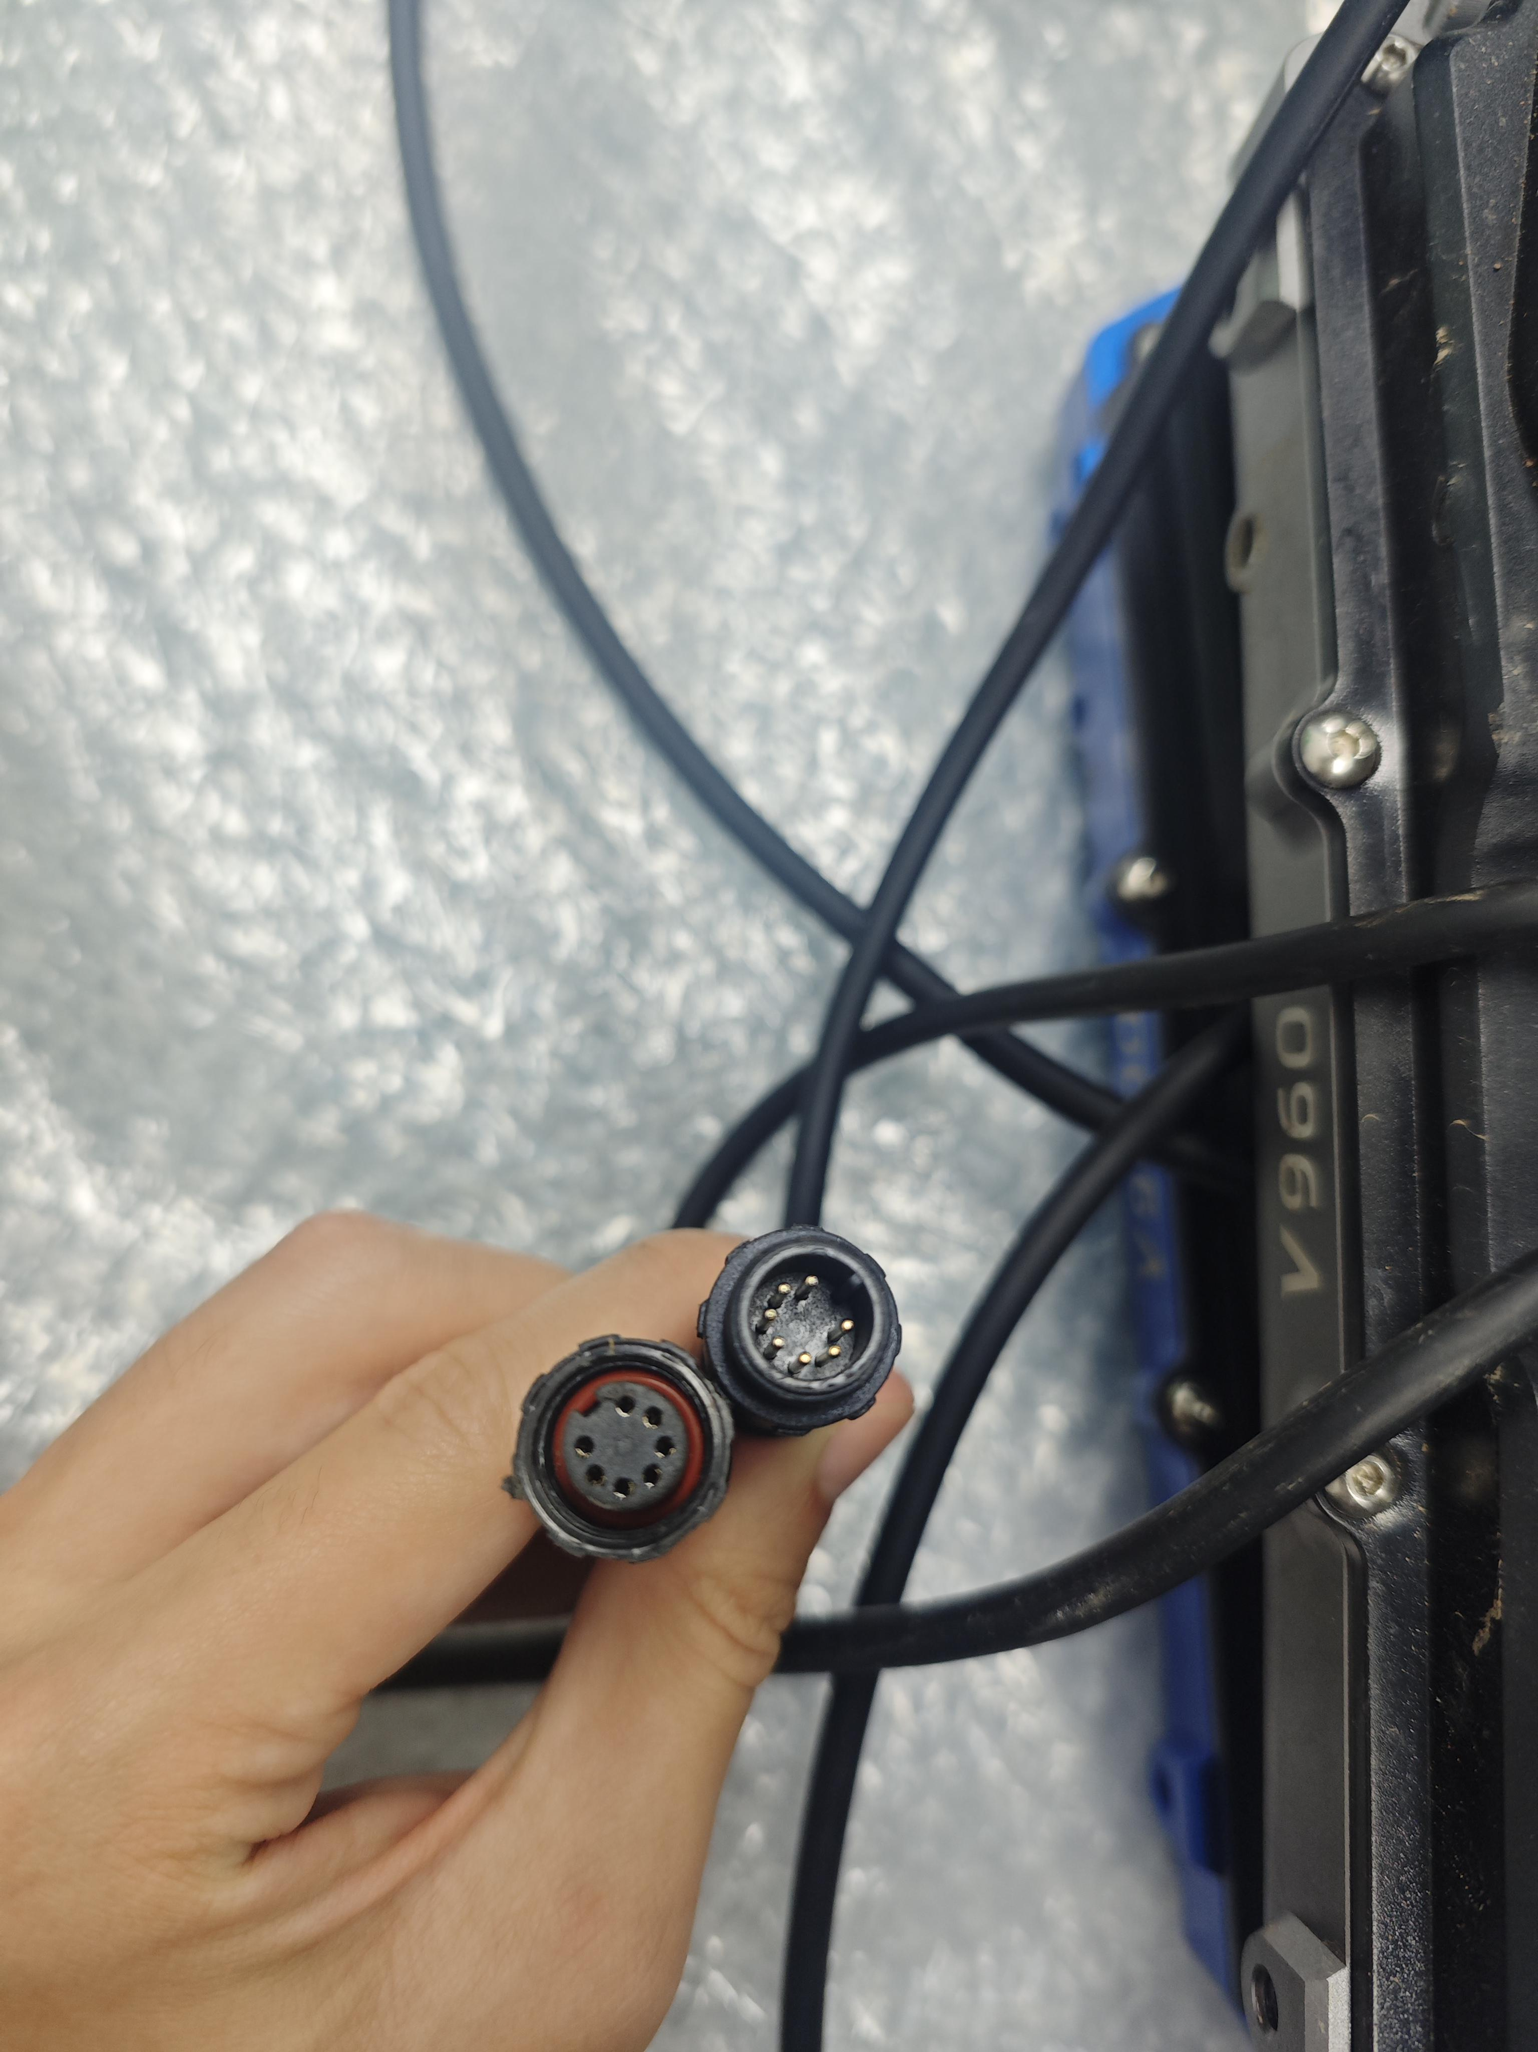
Instructions: Please choose either the general encoder motor adapter or the general Hall motor adapter for installation based on specific requirements; only one is needed. VTB is dedicated to providing comprehensive service to our customers and therefore offers an alternative cable as a backup. We deeply appreciate your support and trust.
Note: When connecting the square plug, a "click" sound indicates that the plug has been securely and correctly connected. If the plug is not fully inserted, it may loosen due to vibrations, resulting in functional abnormalities.
4.Connect the Wiring Harness Plug
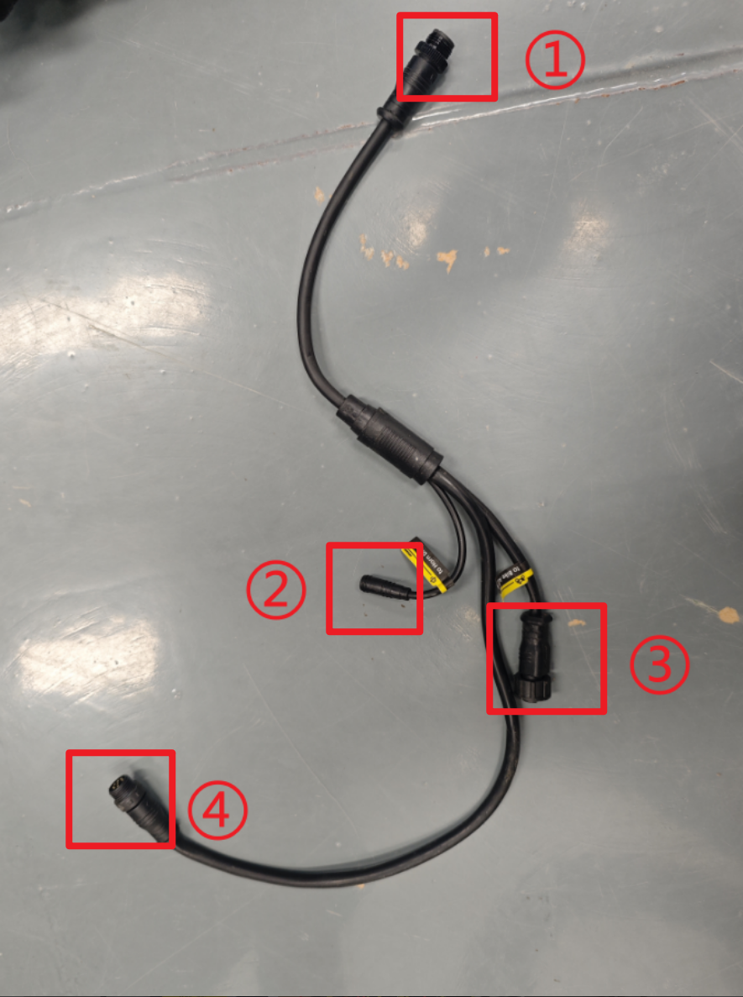
①: Main signal interface of the controller, connected to the longer wiring harness of the controller.
②: Signal interface for the horn button on the switch assembly, connected to the horn driver.
③: Signal interface for the ignition key and vehicle body sensors, connected to the bike adapter.
④: Display communication and throttle grip signal, connected to the display wiring harness.
One end of the Light Bee bike adapter connects to the main vehicle wiring harness functional interface (left image below), while the other end connects to the mid-section harness at Interface ③.The horn driver connects one end to the main vehicle wiring harness (right image below) and the other end to the mid-section harness at Interface ②.
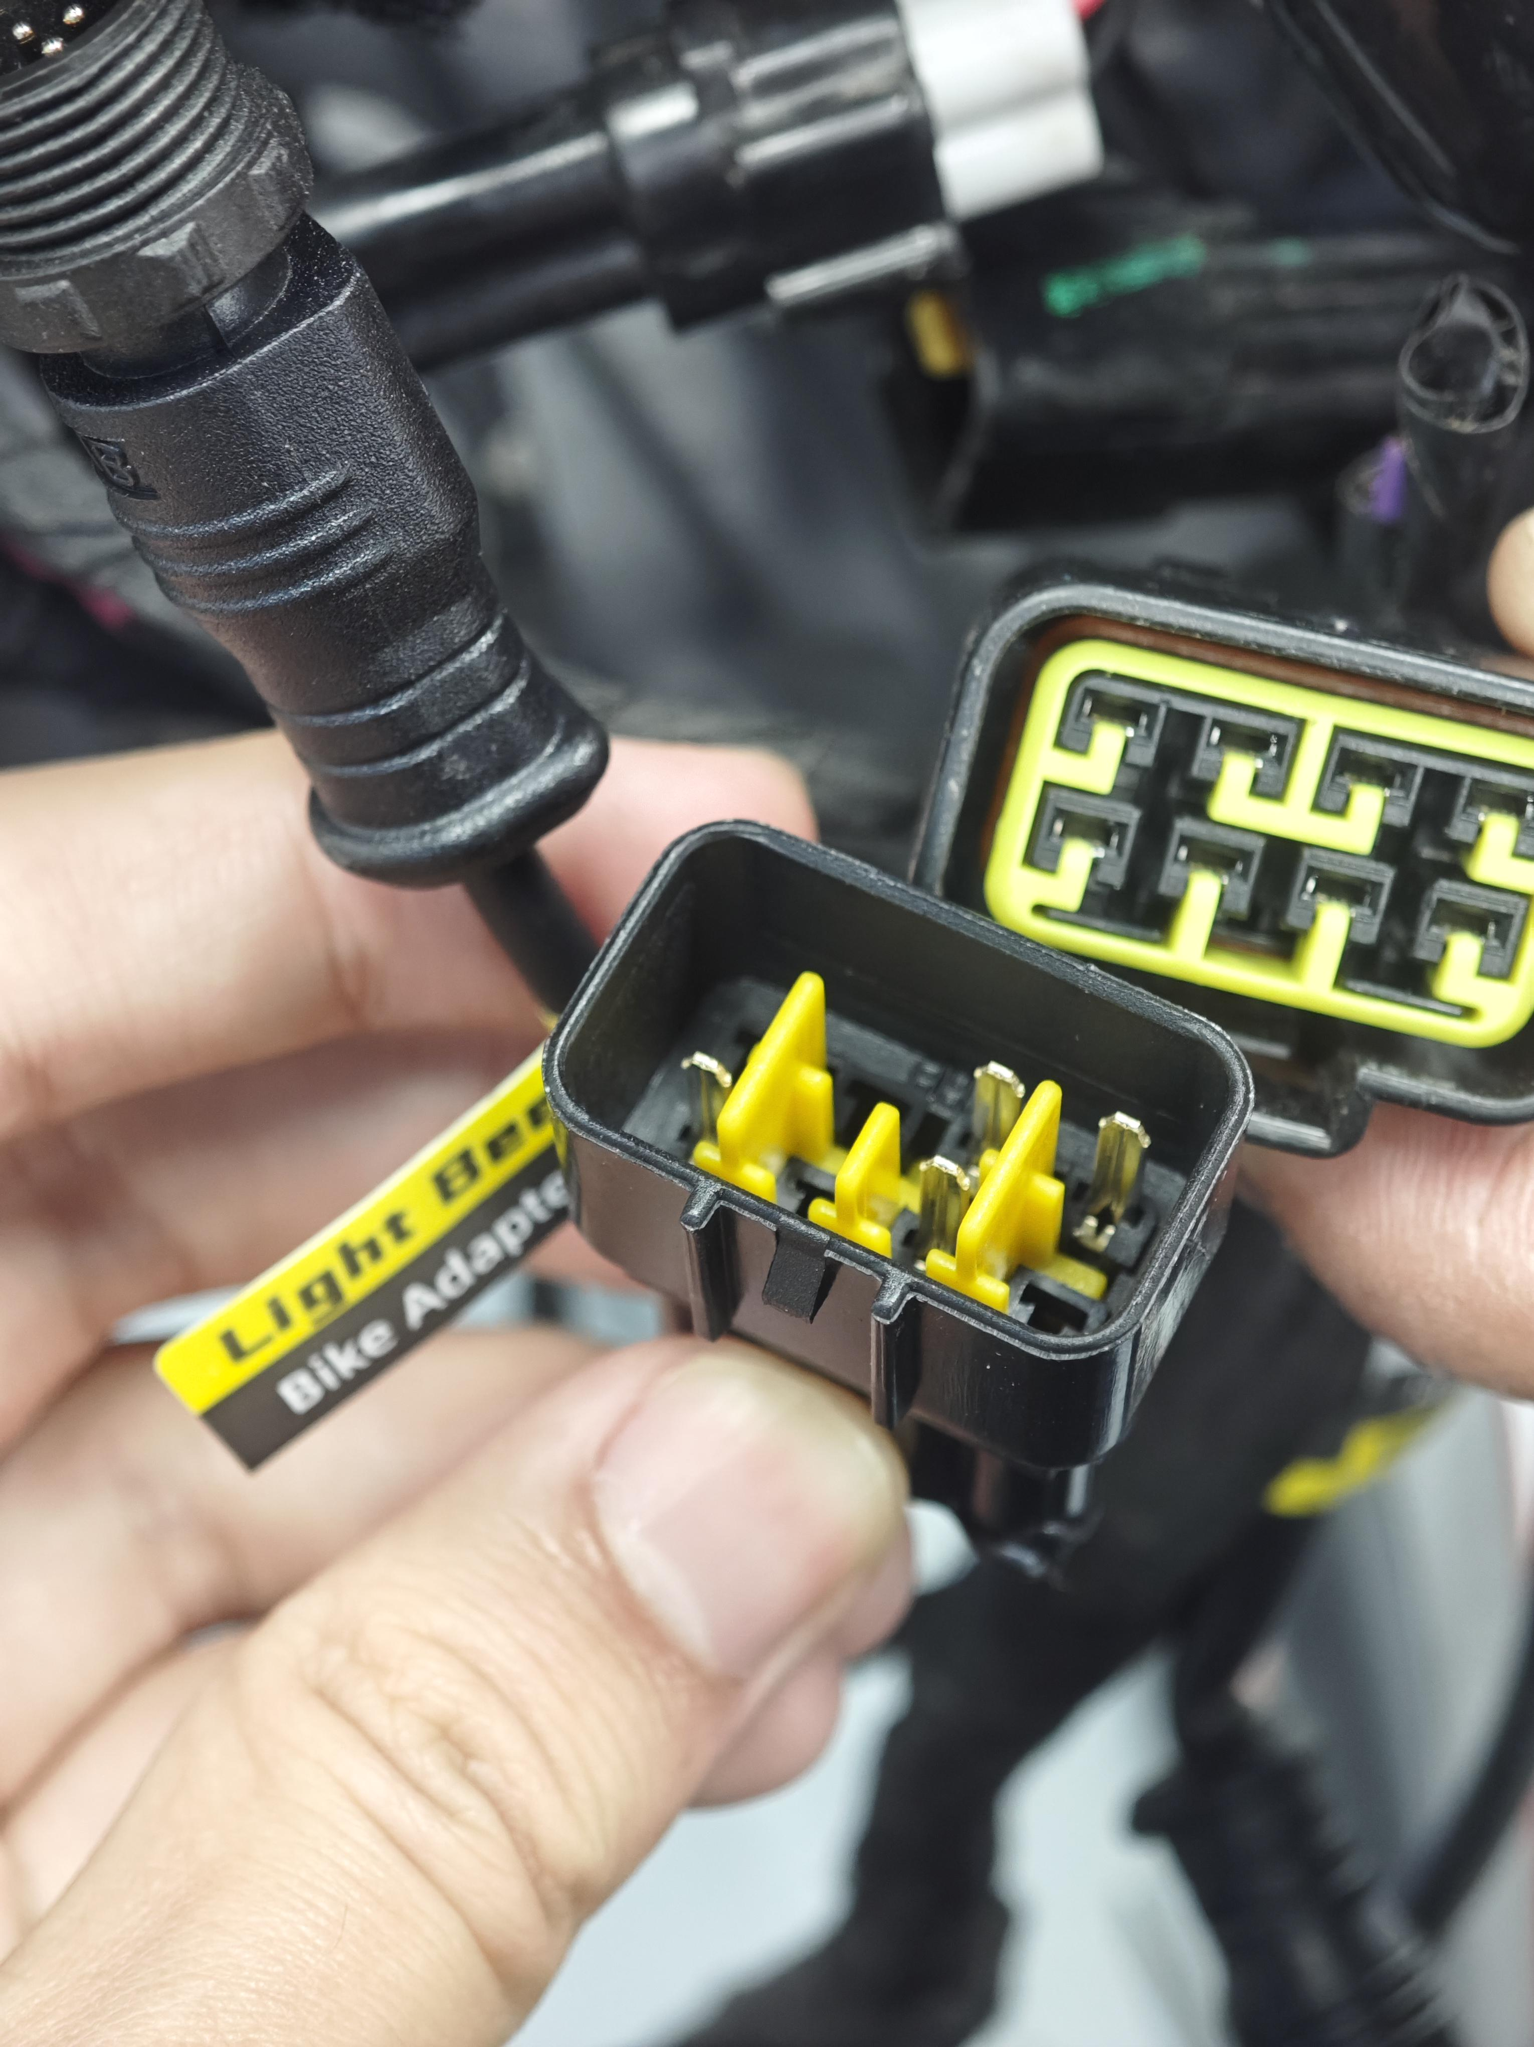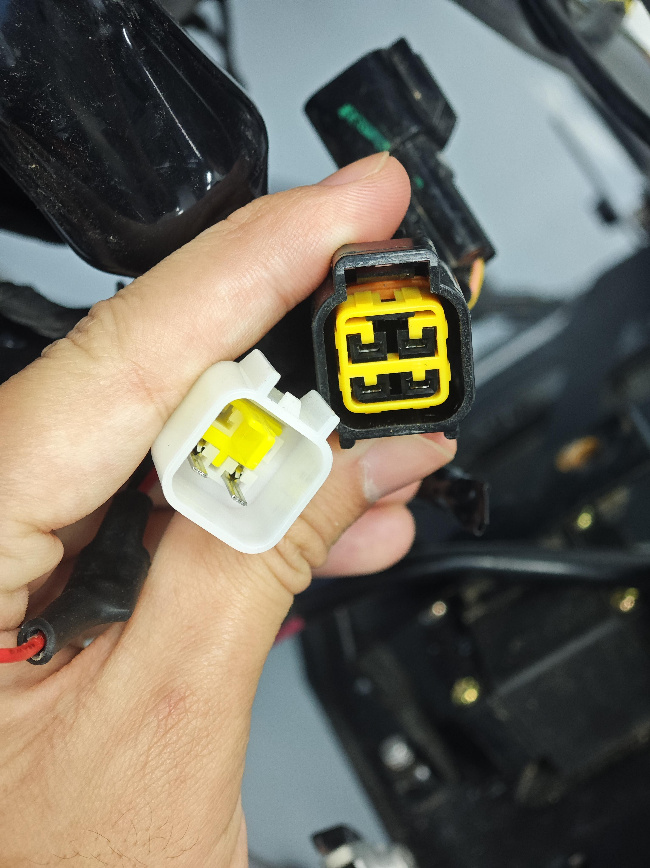
Note: The pins of Interface ① are relatively delicate; exercise caution during connection to prevent misalignment or bending of the pins. When connecting the square plug, a "click" sound indicates that the plug has been securely and correctly connected. If the plug is not fully inserted, it may loosen due to vibrations, resulting in functional abnormalities.
5.Organize the Wiring Harness
Before organizing the wiring harness, it is recommended to trim the unnecessary plugs from the original vehicle's main wiring. These include two of the three controller plugs, as well as the throttle grip plug and the display plug. The positions and interfaces for trimming the plugs are illustrated in the accompanying diagram.
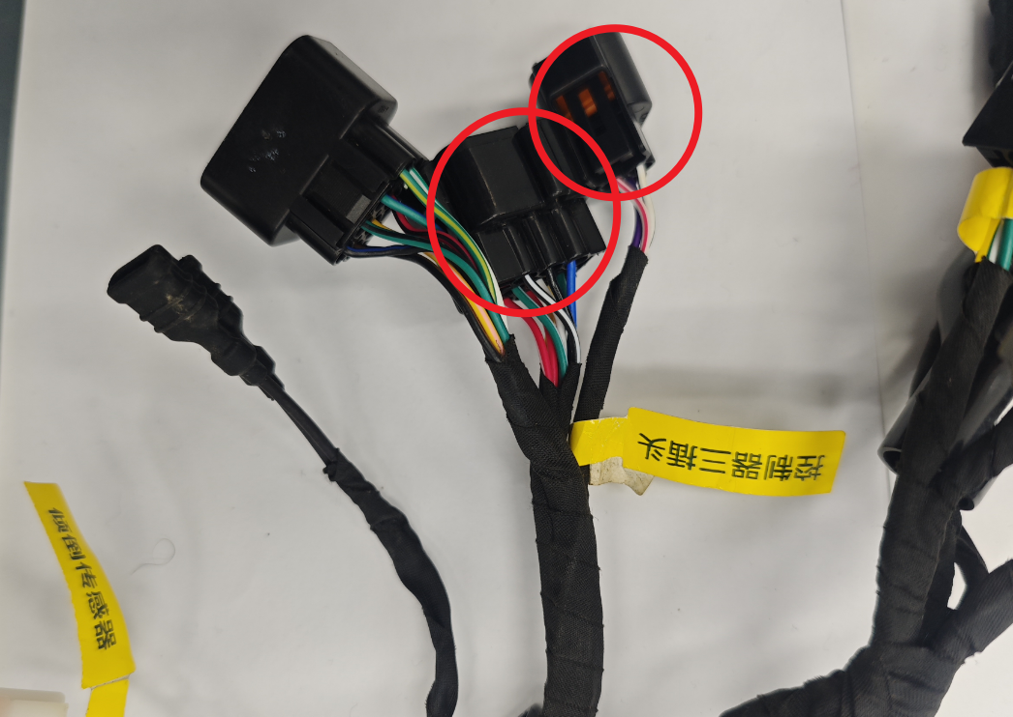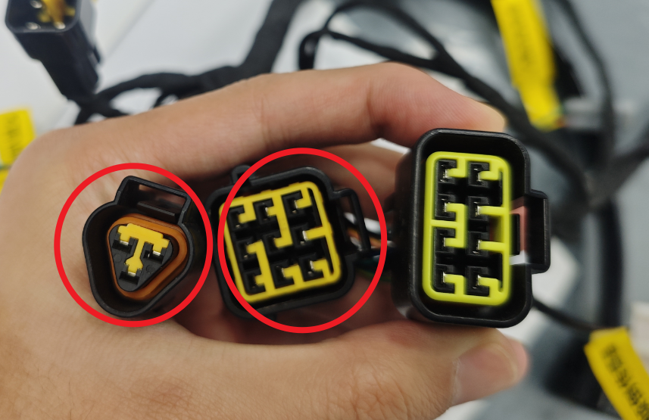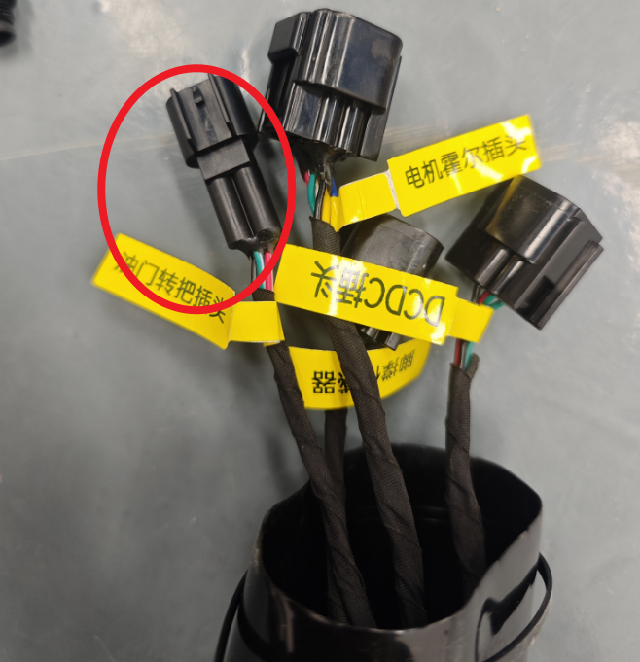
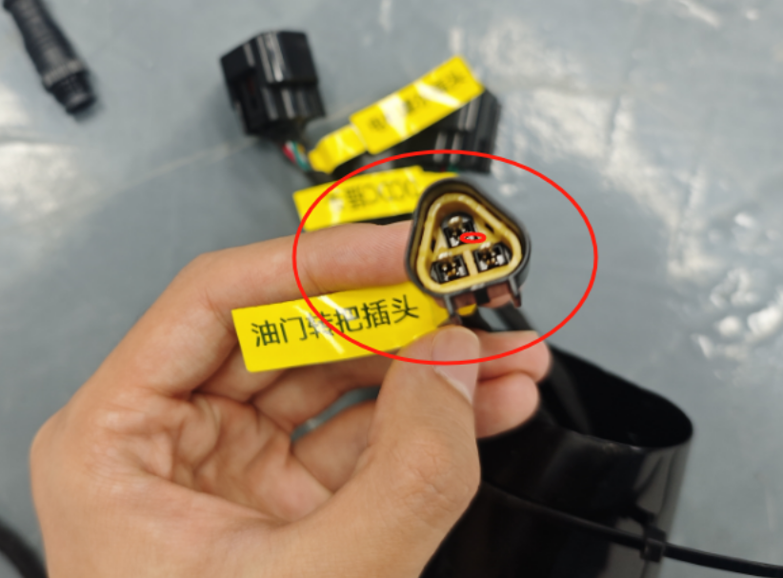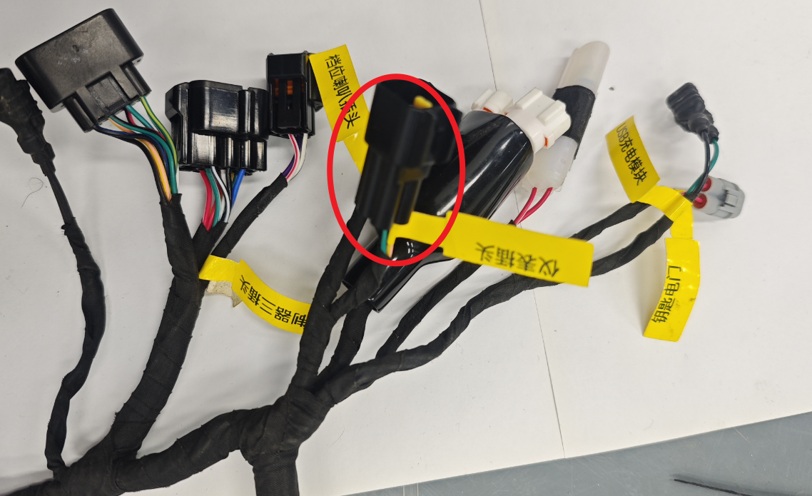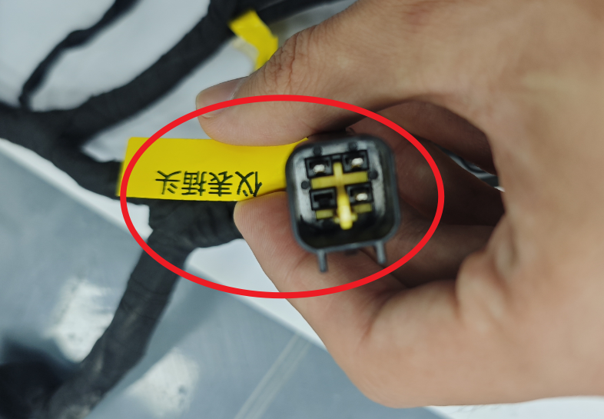
Note: When trimming the wiring harness, ensure an angled cut to keep the pins staggered and prevent short circuits. After cutting, wrap the pins with insulating tape.
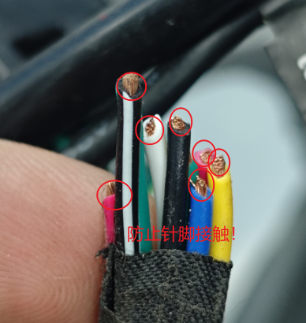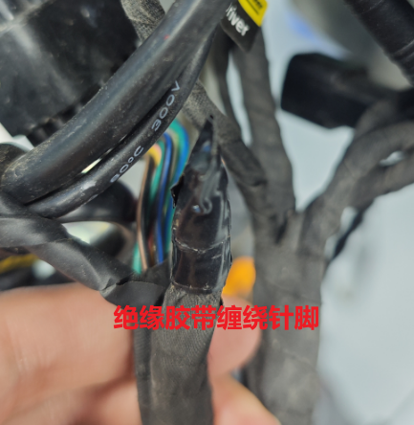
Place the wiring harness above the controller in front of the battery cover, while the lower wiring harness should be positioned in the space above the motor's bottom cover. Guide the mid-section harness with connector ④ along the sides of the controller, through the start switch position, and connect it to the display, placing it in the outer compartment (as shown in the bottom left image). Once the wiring in the outer compartment is organized (as shown in the bottom center image), install the license plate (as shown in the bottom right image).
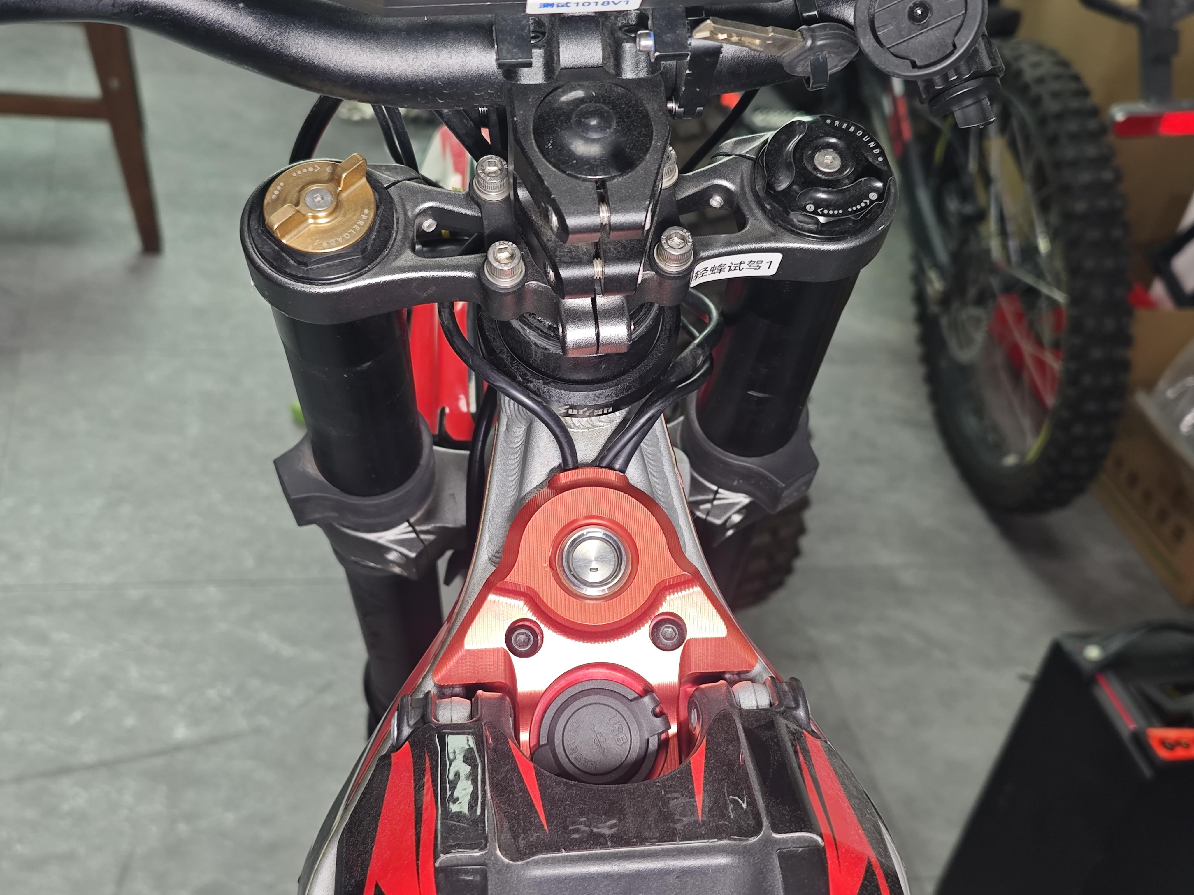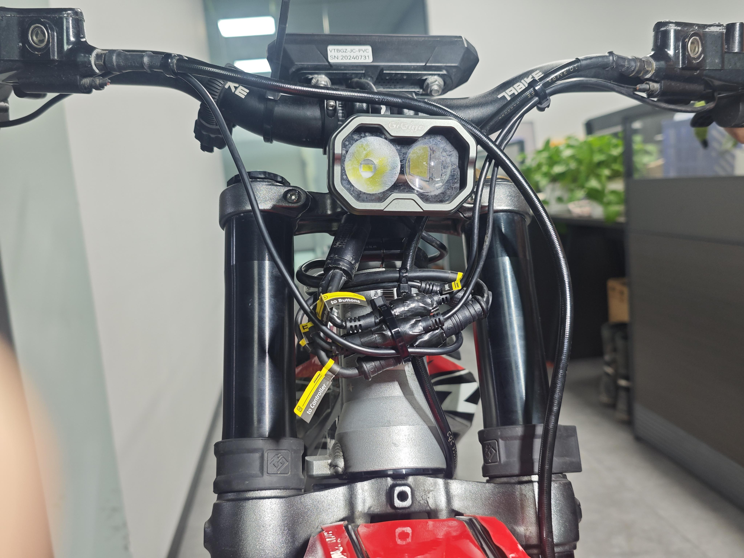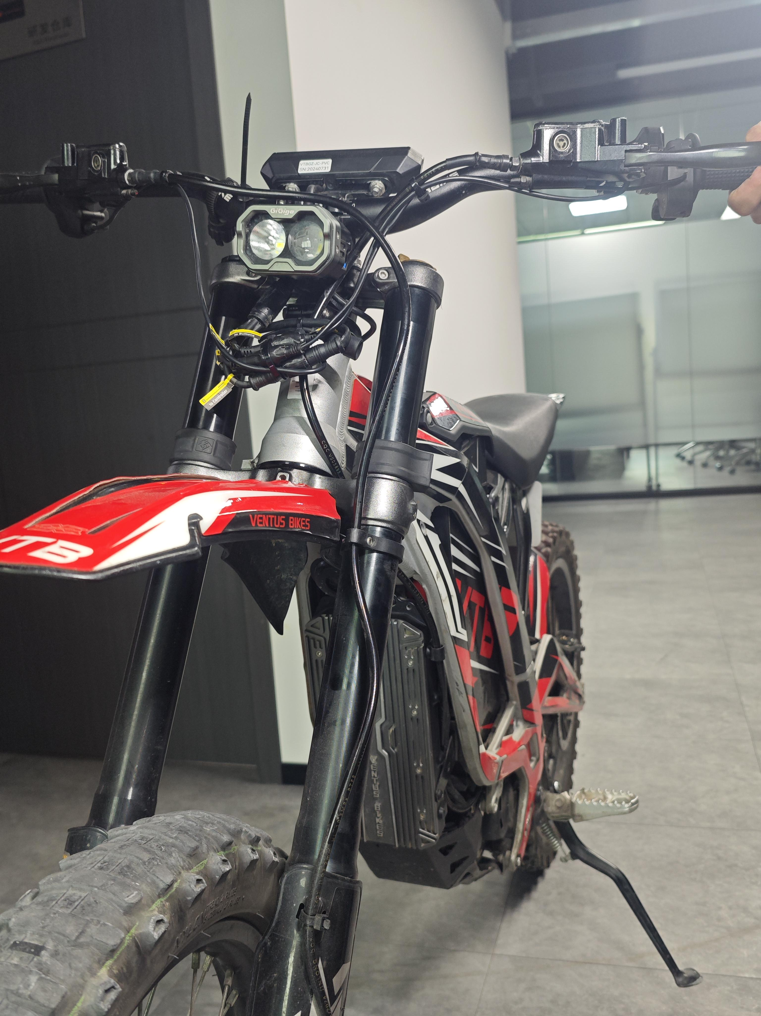
Note: During the arranging of the wiring harness, it is crucial to avoid pinching or squeezing the wires. Ensure that they are not pulled or compressed when the handlebar rotates.
6.Fastening the Front Battery Panel
Attach the screws on both sides of the chassis to securely anchor the front battery panel, ensuring it remains stable and free from vibration.
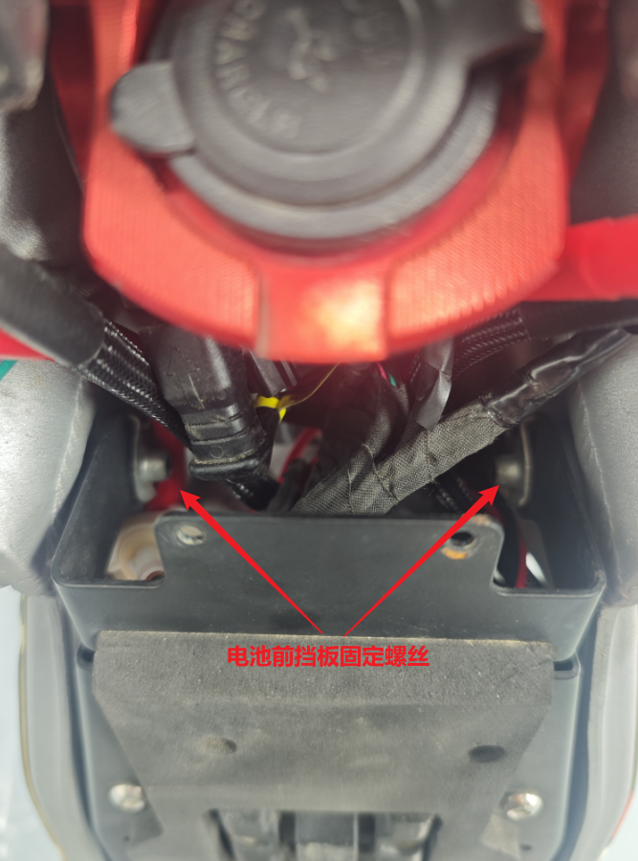
7.Installing the Controller
Begin by aligning and securing the lower mounting holes of the controller using screws from the accessory kit, fastening them with a wrench. Adjust the position of the controller to align with the lower mounting holes, then tighten the screws with a wrench. Secure all four mounting screws tightly to ensure the controller is stable and free of movement, and finally, tighten the screws on the top of the motor cover to complete the installation.
Note: Ensure the installation area is sufficiently clear, and check through the gaps in the front battery panel for any pinched wires around the controller. Initially, do not over-tighten the top screws to allow for adjustments when aligning the lower mounting holes.
The installed controller should appear as shown in the illustration below.
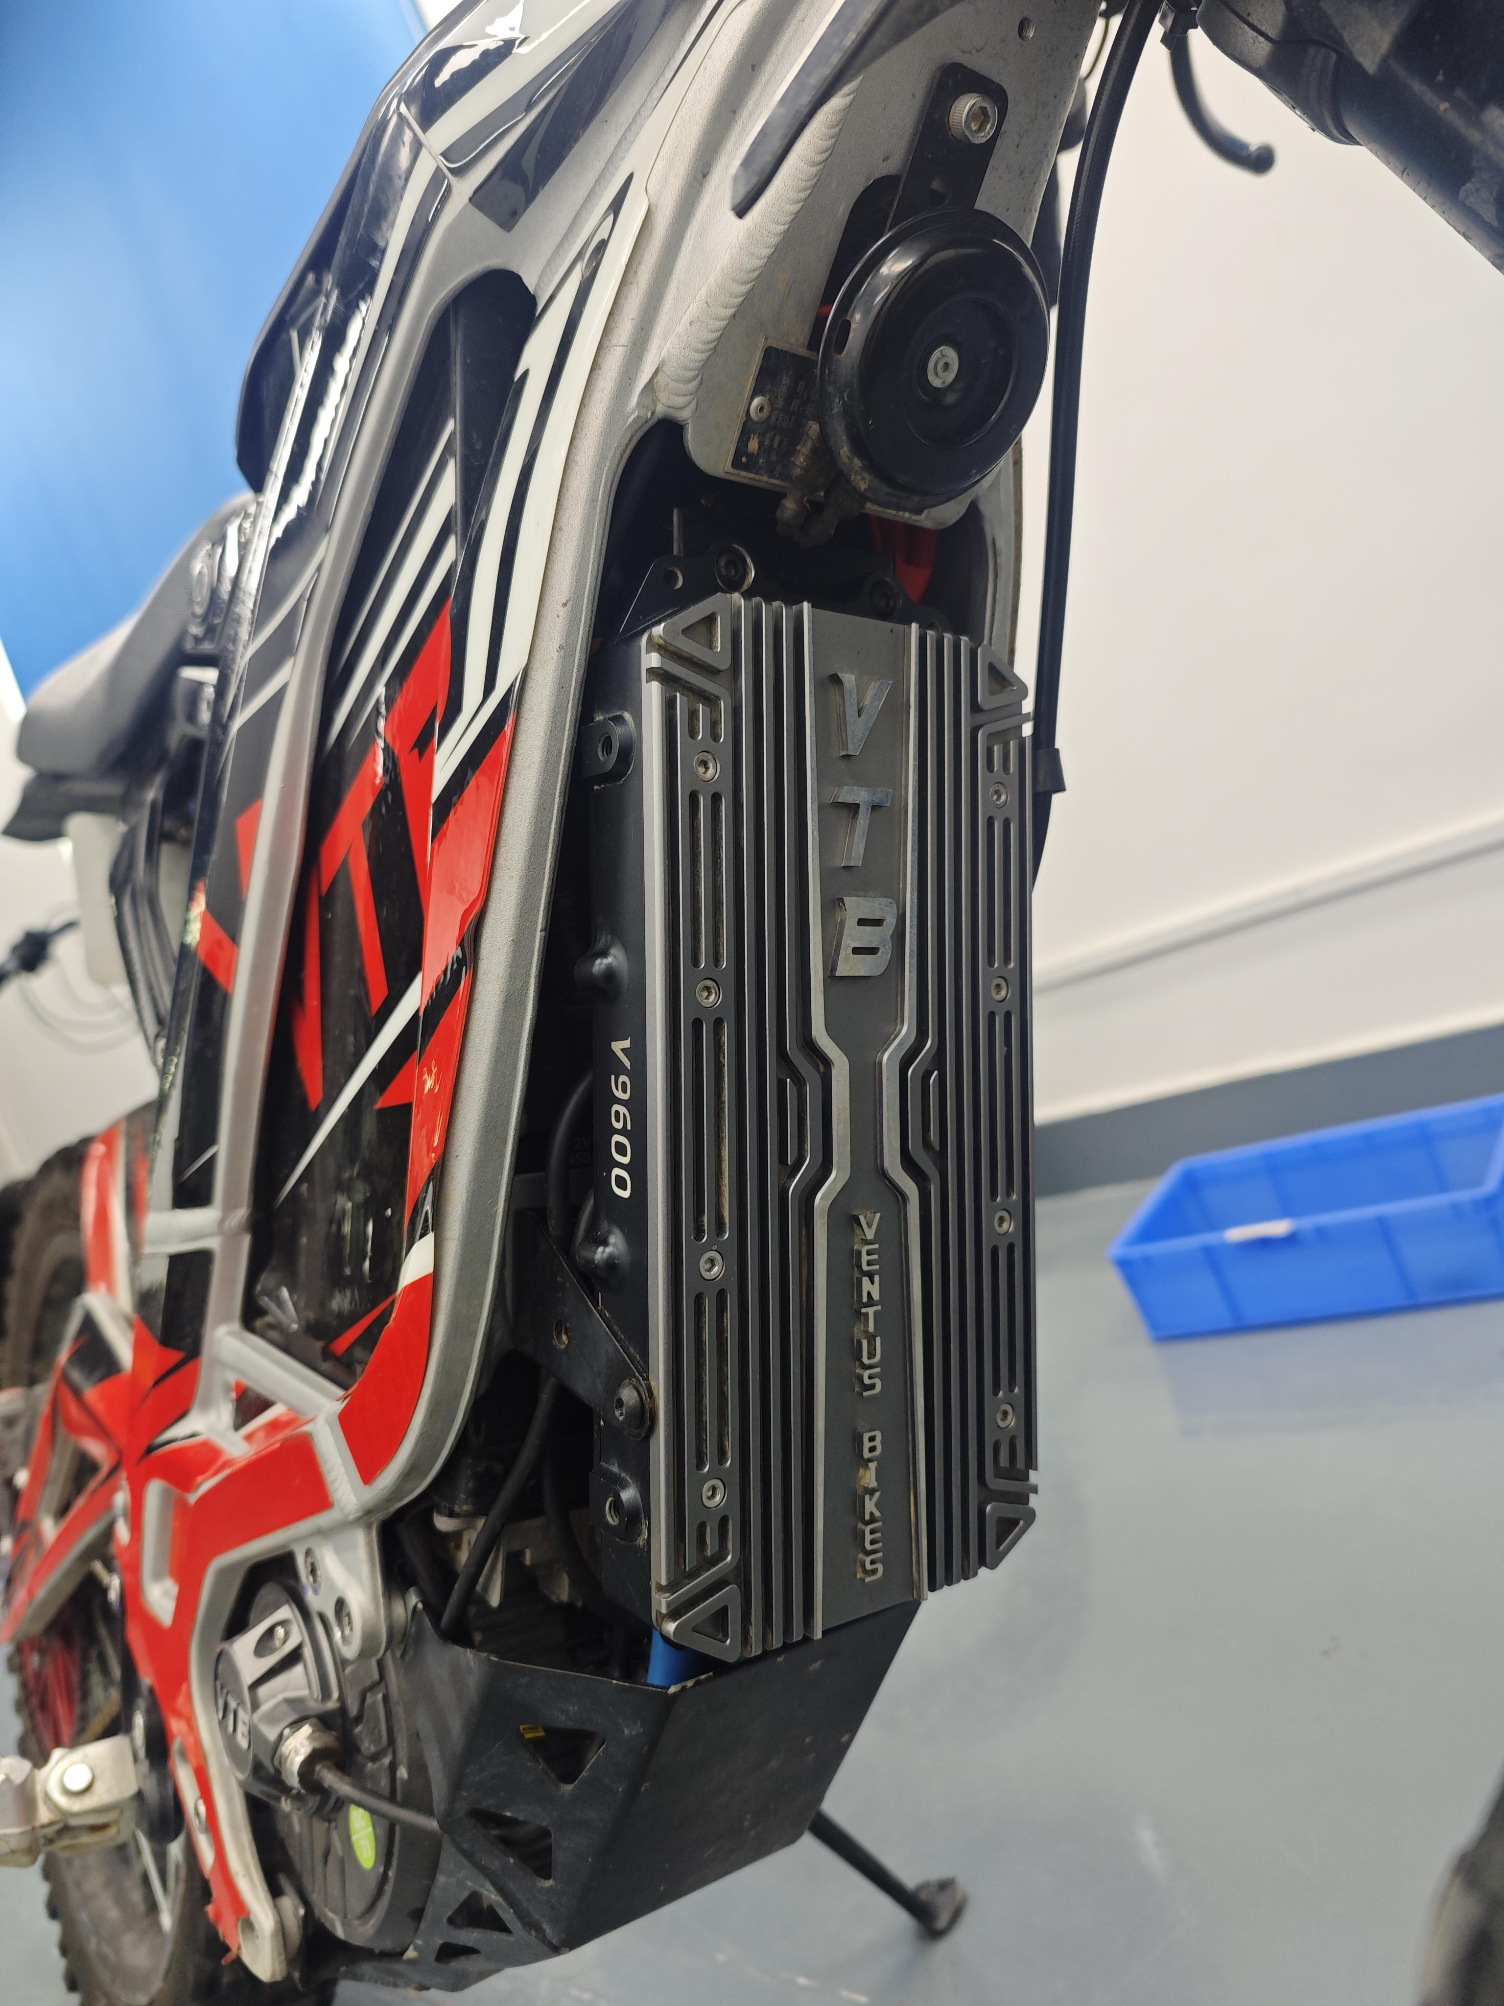
8.Controller Setup Guide
After installing the controller, open the app and select the vehicle model on the main page to automatically enter the controller setup guide. Follow the instructions to complete the setup. During the guide, observe the wheel rotation direction during motor calibration. If it rotates correctly (forward) and a success message appears, the setup is complete.If not, select the alternative direction for calibration. Once familiar with the app's operations, you can independently perform motor self-learning, throttle calibration, or regen brake （thumb brake）calibration in the advanced settings.
Special Note: At the end of the throttle calibration, you need to select a gap; for normal use, choose the standard gap. The throttle gap refers to the minimum throttle opening needed for a response, with the ultra-small gap being even smaller than the standard gap.
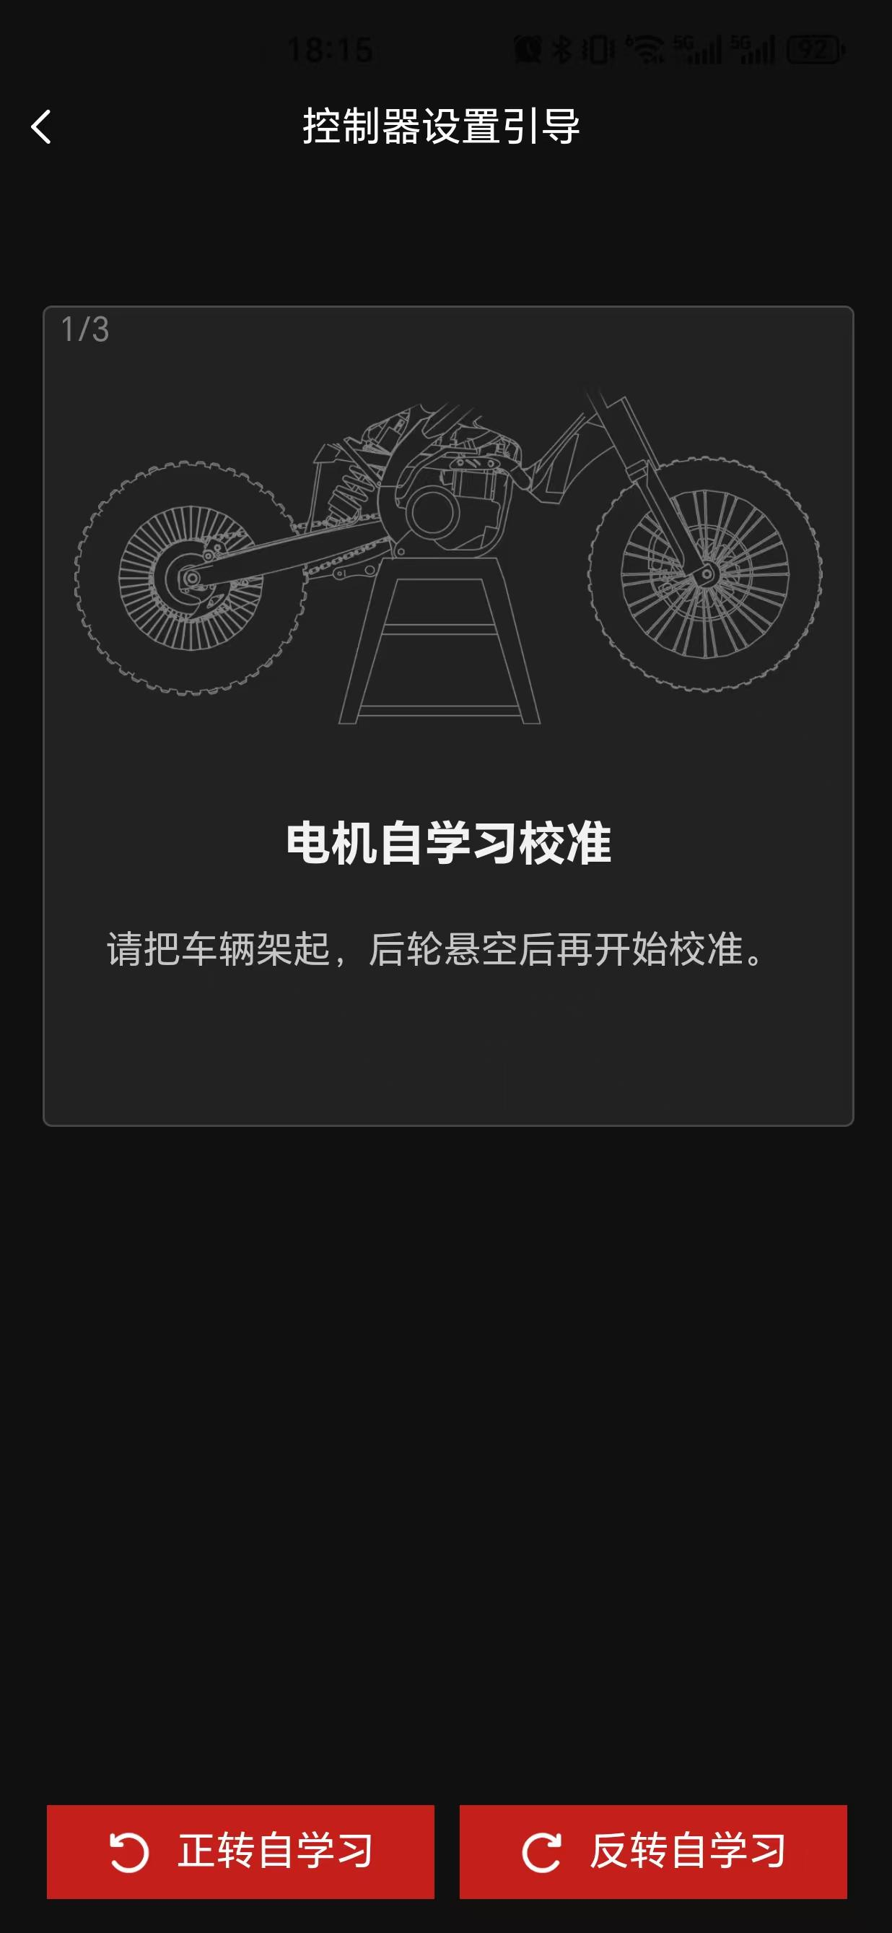
When adjusting battery or motor settings, you must first click on "Unlock" in the upper-right corner of the page and enter the unlock password: 123686, before making any changes.

Special Note: Exercise extreme caution when altering battery or motor settings, as such modifications are not recommended for general users. The advanced settings are designed to meet the needs of users seeking a more refined and precise experience. The password is implemented as a safeguard to ensure the safety of non-professional users.
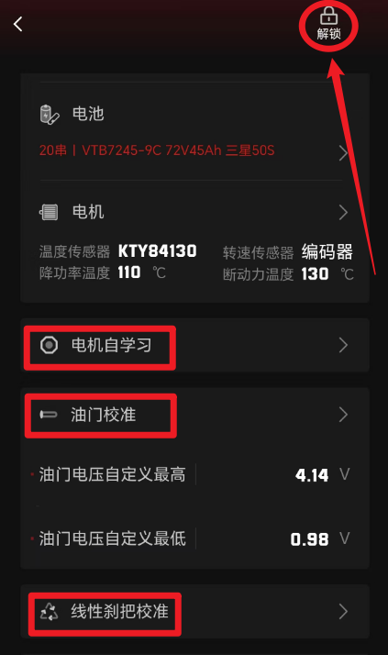

IV. Supporting Components
1.Color Display
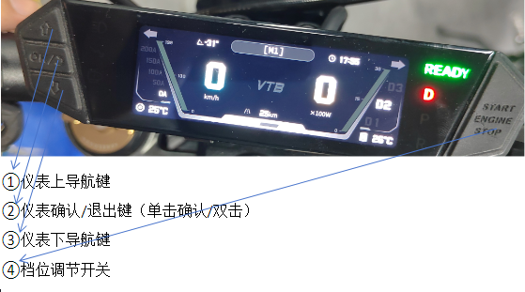
During the installation of the display, you can adjust its position by modifying the installation method of the versatile bracket to suit various riding scenarios, such as off-road or on-road conditions. The installation method of the versatile bracket varies slightly depending on the type of stem. Common stem types include standard stems and double-clamp stems. The following installation guidelines are for reference only; specific installation should be tailored to individual needs and actual circumstances.

For off-road scenarios, it is recommended to install the display behind the stem to provide maximum protection. The primary difference between standard stems and double-clamp stems lies in the orientation of the display bracket clamp. The installation effects are illustrated as follows:
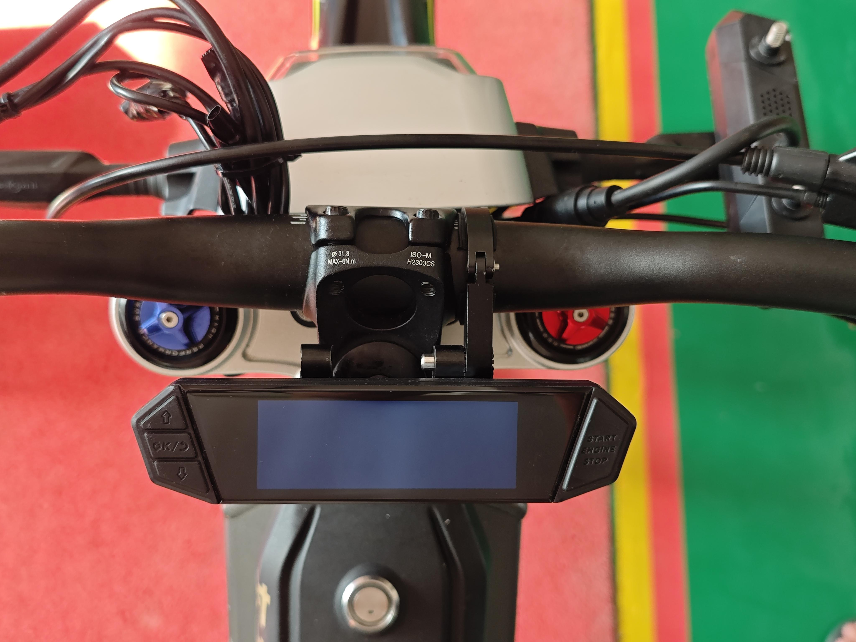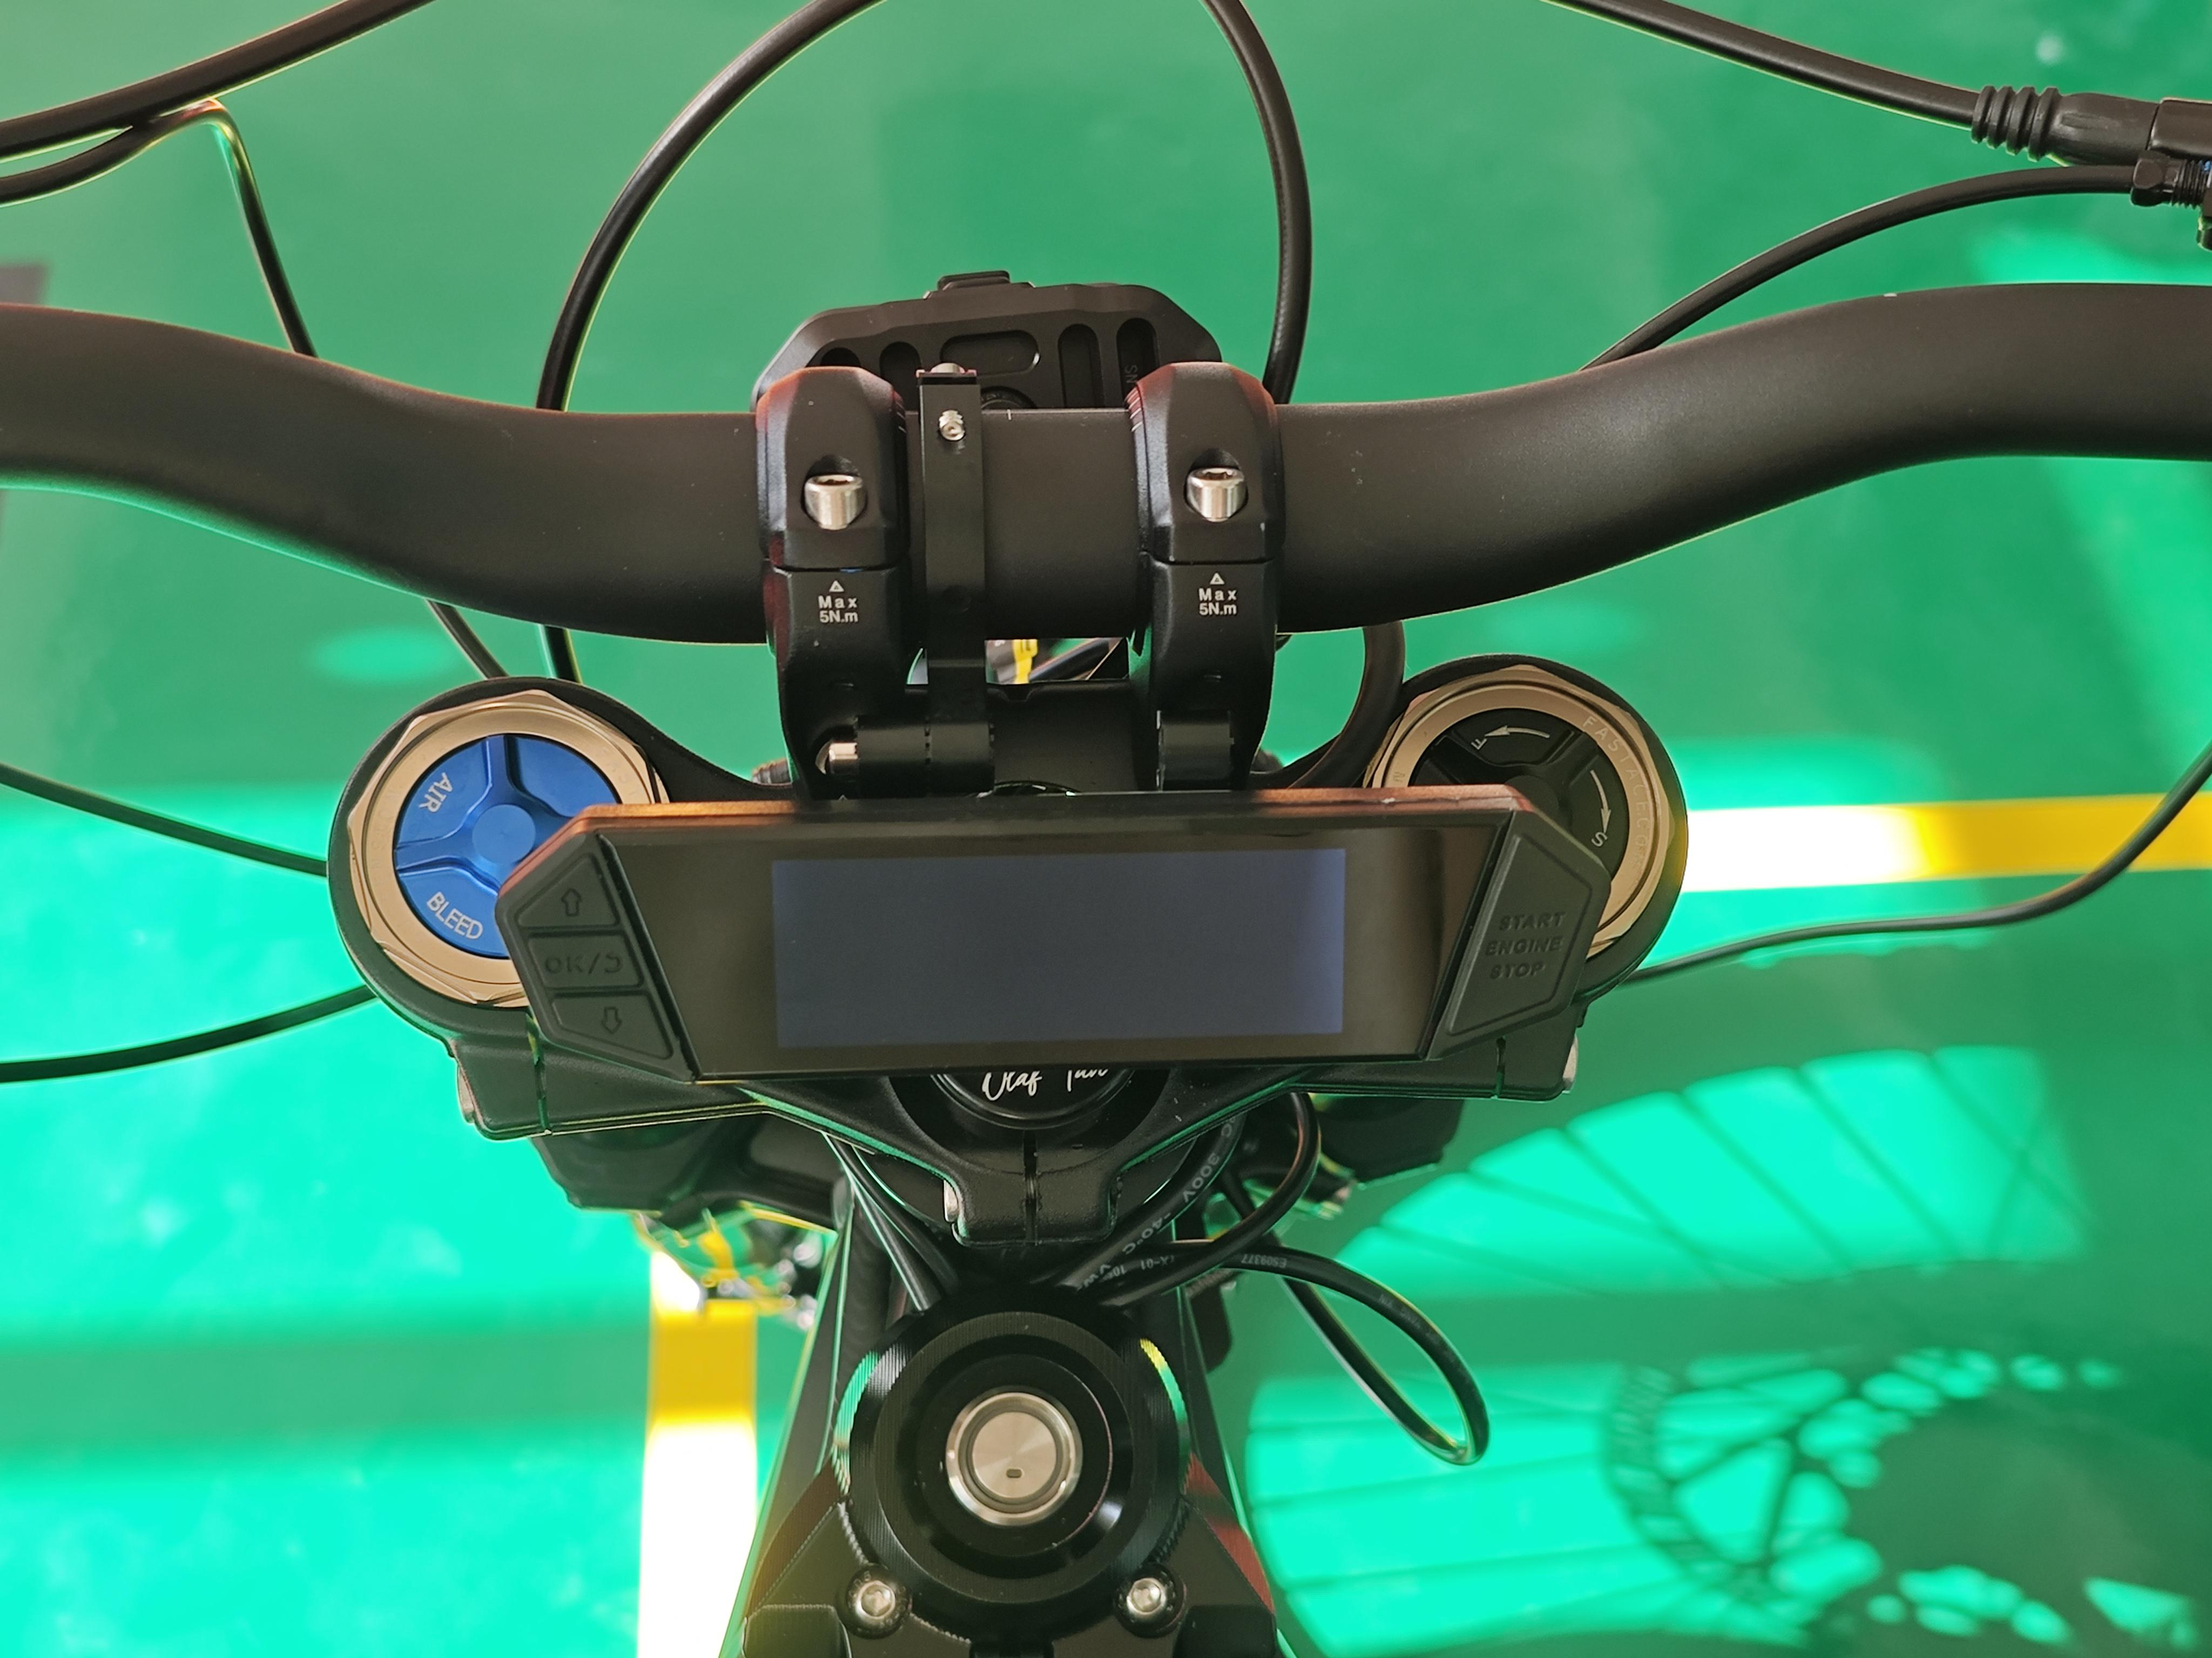
For on-road scenarios, it is recommended to mount the display above the stem to enhance the overall aesthetic of the vehicle. The difference between standard stems and double-clamp stems lies in the orientation of the display bracket clamp. The installation results are demonstrated as follows:
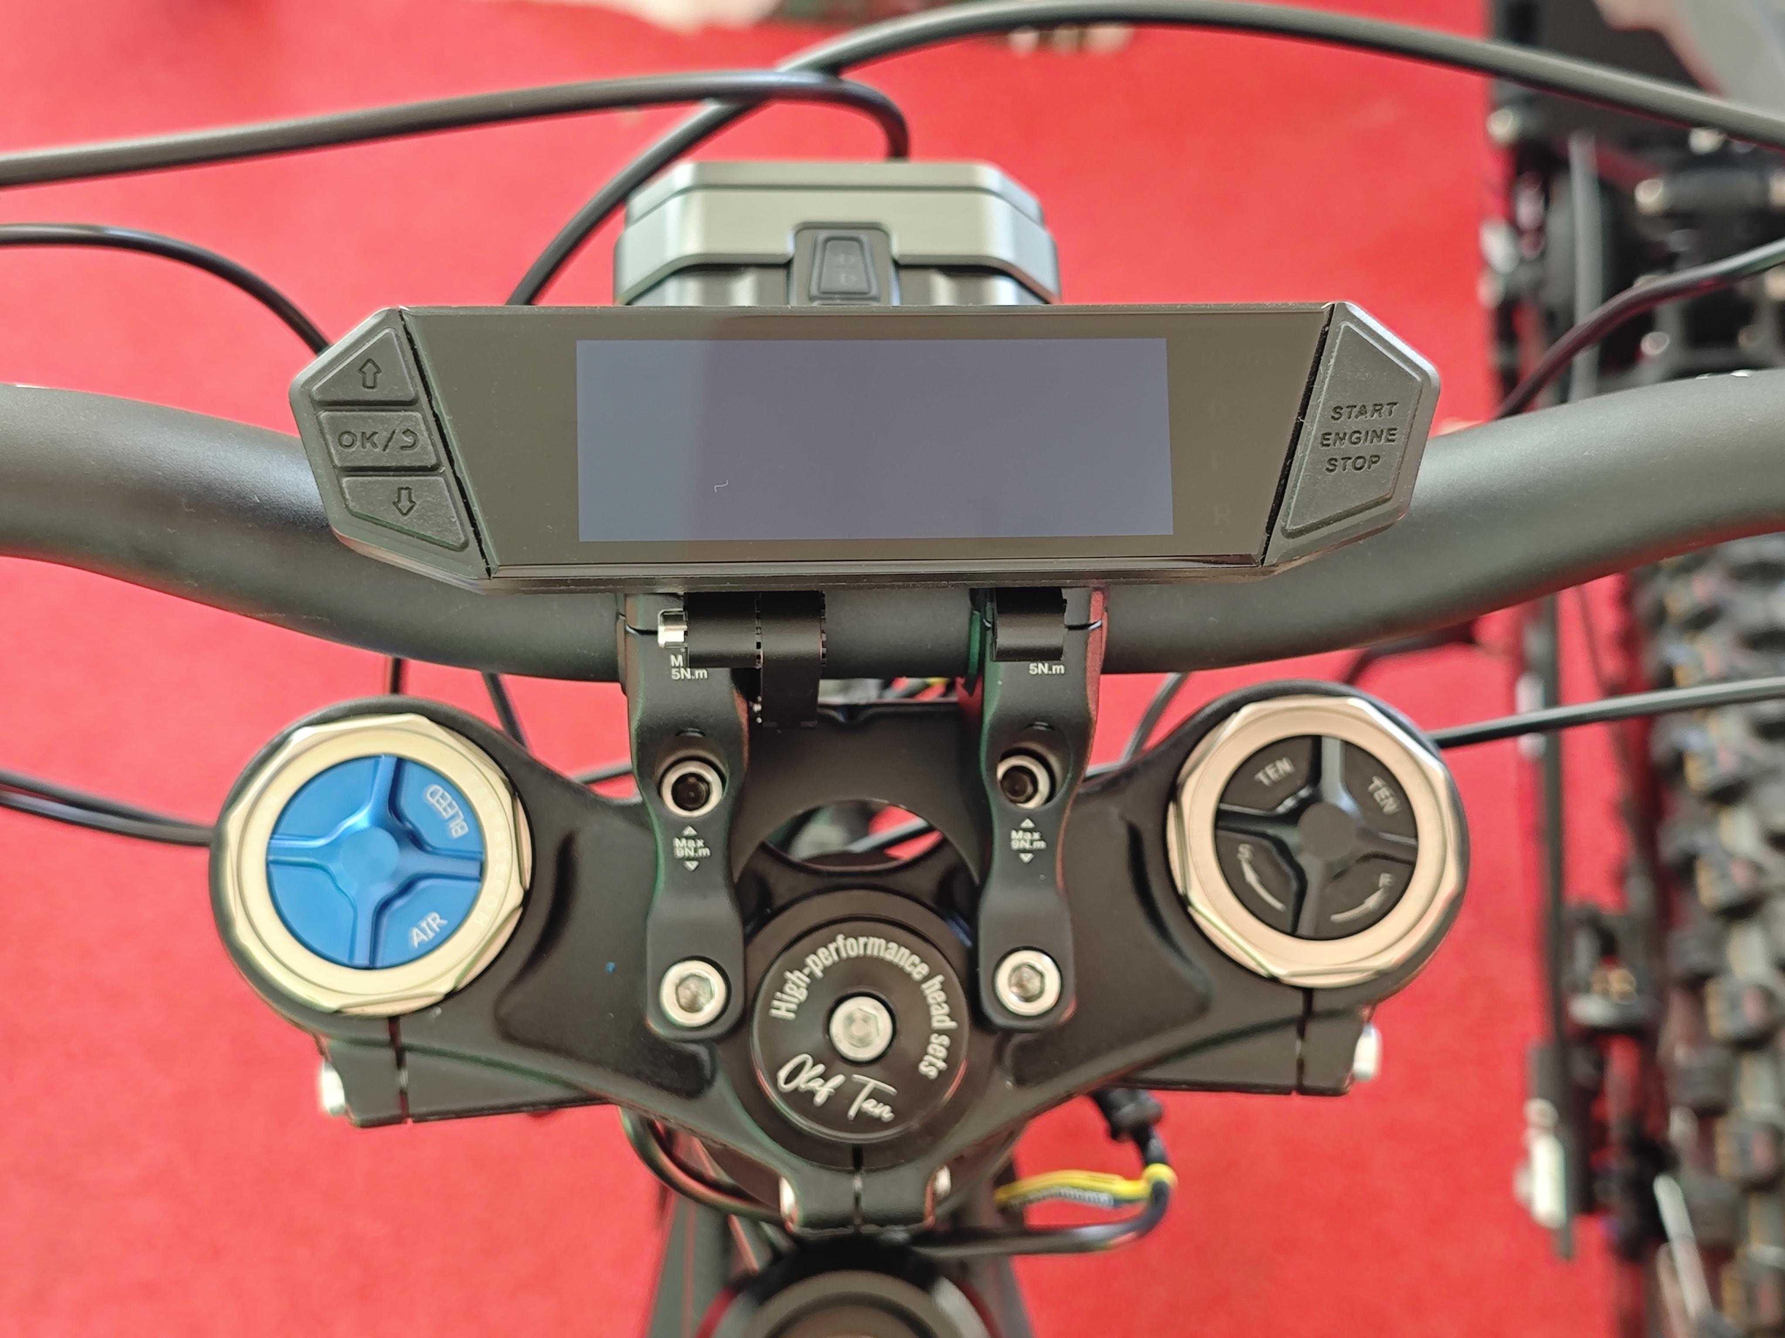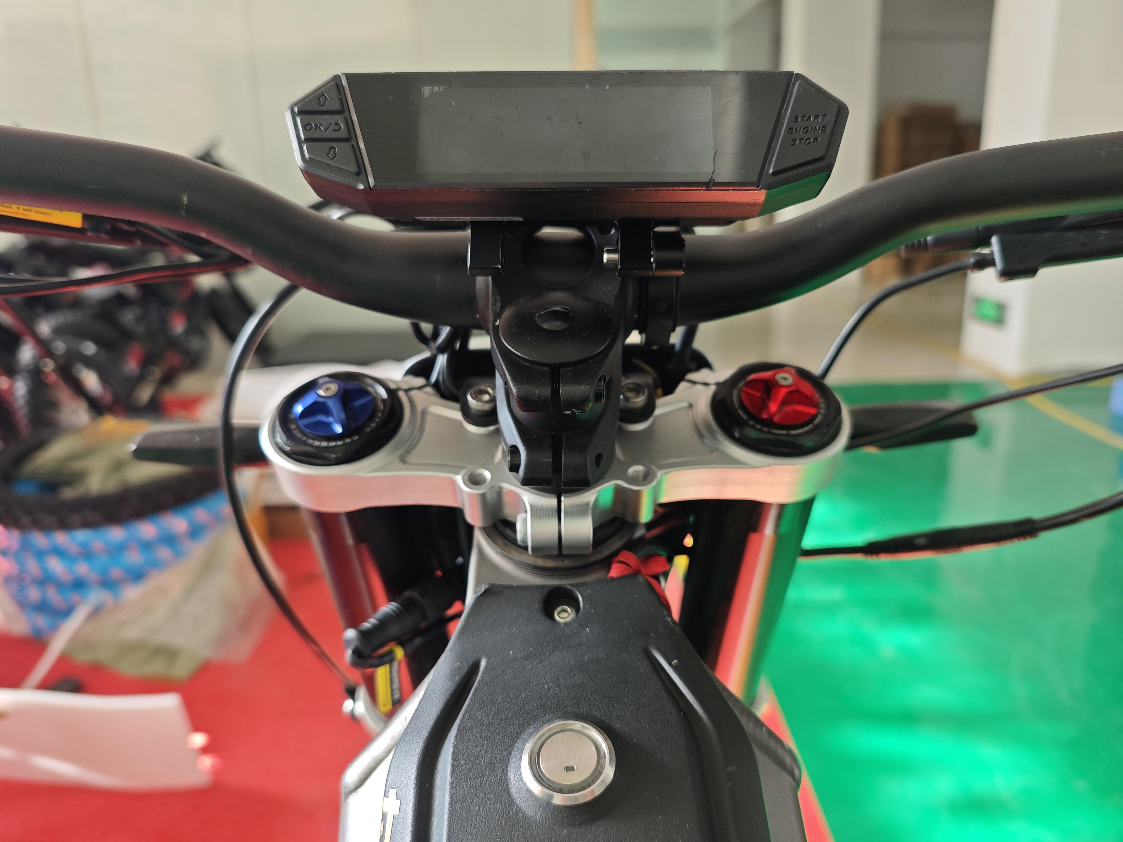
2.Combination Switch and Regen Brake（Thumb Brake）

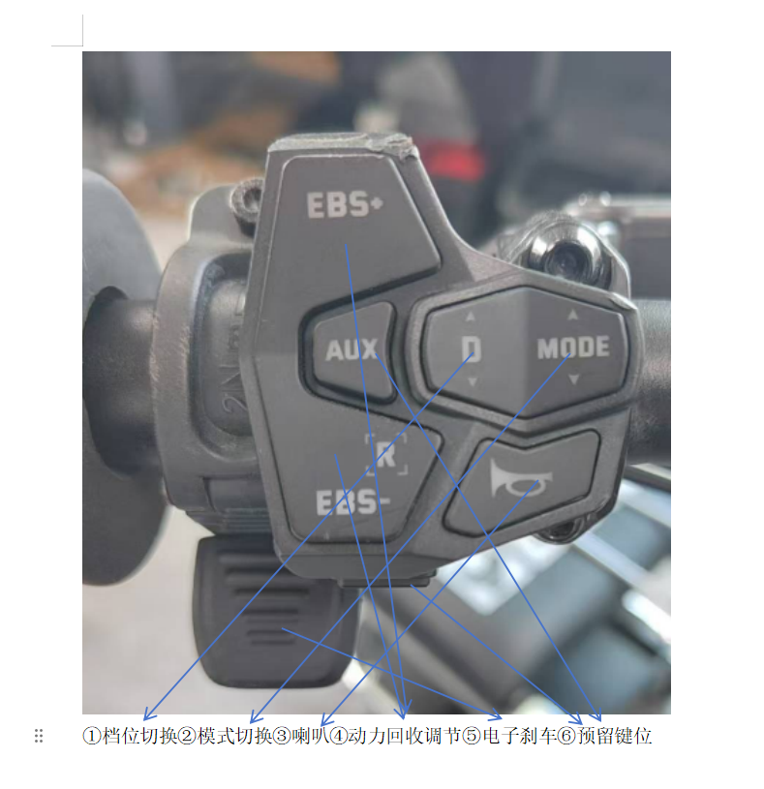
The combination switch and regen brake（thumb brake）are designed to integrate seamlessly during installation, ensuring an optimized operational feel while conserving installation space.

Note: There should be an appropriate gap between the regen brake and the handle grip. Insufficient spacing may hinder the regen brake’s proper reset function, while excessive spacing could compromise the comfort of use.
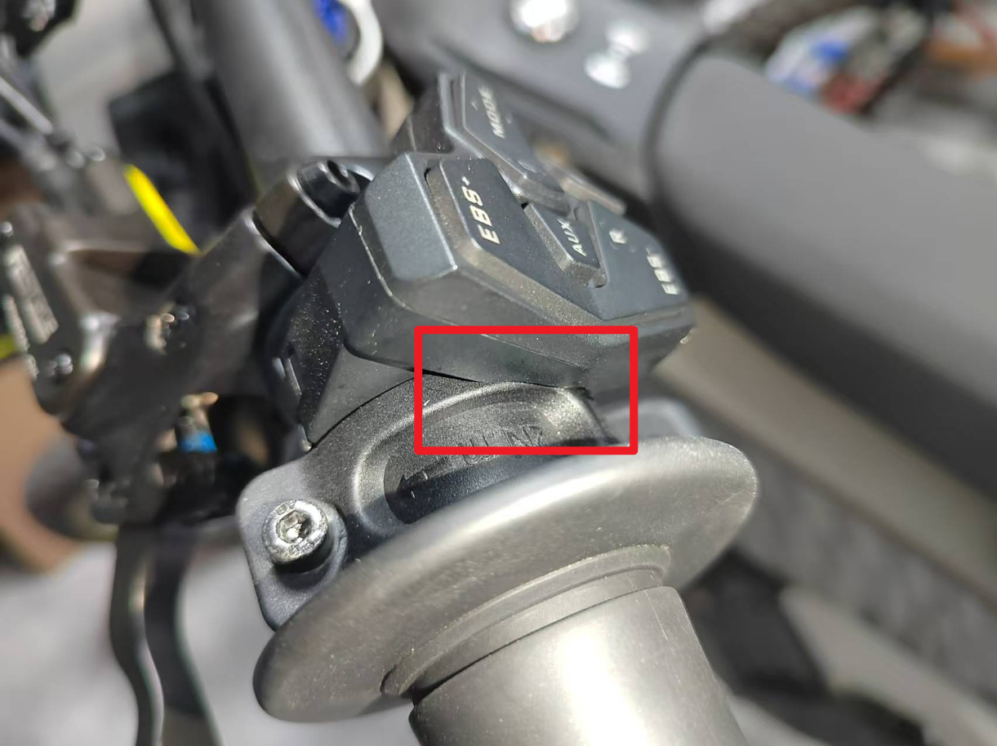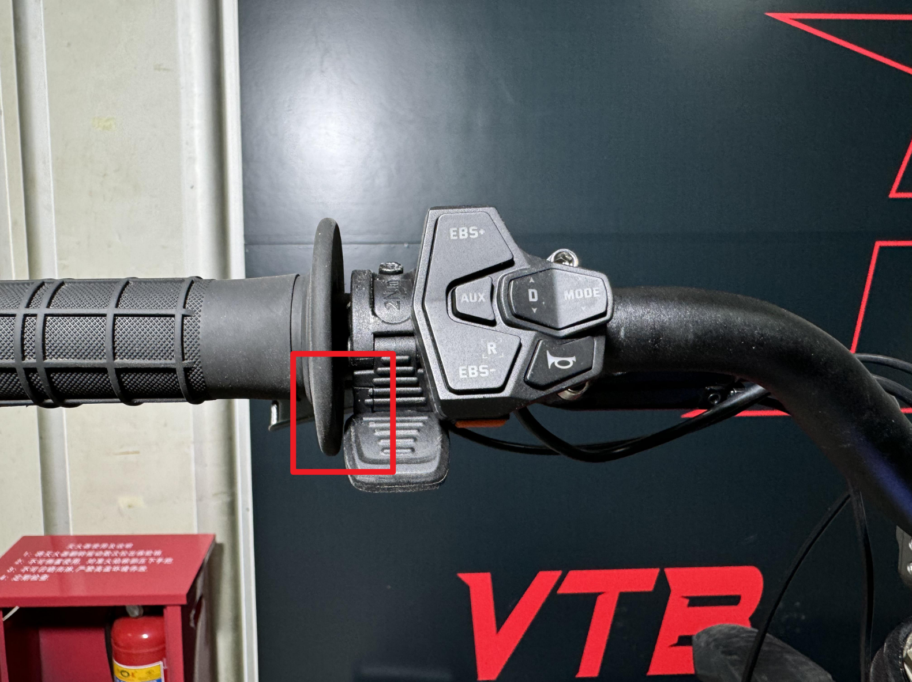

V. APP Connection and Configuration
1.How to Connect
Download and install the VTB application. Ensure that your phone's "Bluetooth" and "Location Information" or "Location Services" are enabled. Confirm the vehicle is powered on and that the app has obtained the necessary Bluetooth and location permissions. On the main page, select the controller name and tap to connect. Once connected successfully, the current status of the vehicle will be displayed.
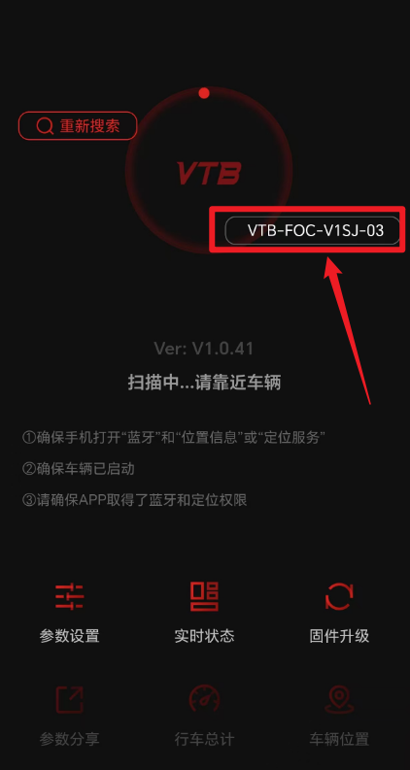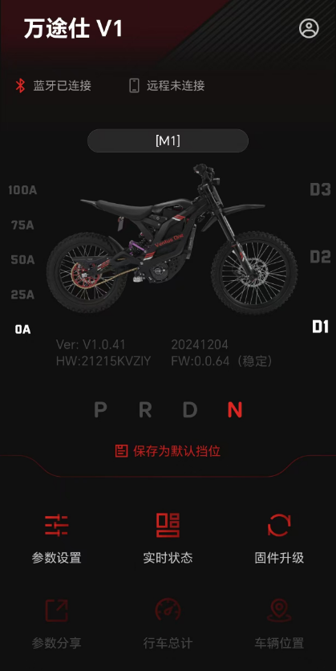
2.Parameter Configuration
◎Parameter Overview — Sensory Parameters
Speed Adjustment: This sets the maximum speed for the selected gear, which corresponds to the top speed achievable when the throttle grip is fully opened. A lower speed adjustment enables finer throttle control, offering a more nuanced and delicate tactile experience, as the same throttle input manages a smaller range of speeds. When the speed adjustment exceeds 50%, field weakening mode is activated, allowing for a higher maximum speed. However, this comes at the cost of reduced motor efficiency and faster battery depletion.

Traction Adjustment: This parameter adjusts the torque at the wheels by configuring the motor's maximum phase current, directly determining the motor’s torque and power output. A higher phase current enhances the vehicle's acceleration performance at low speeds. For instance, when the motor’s phase current is low, even with a large throttle input, the speed changes smoothly, providing a more comfortable riding experience. Conversely, with a higher phase current, even minimal throttle input results in more pronounced speed changes, delivering a sharper, more aggressive riding sensation with a strong sense of "pull."
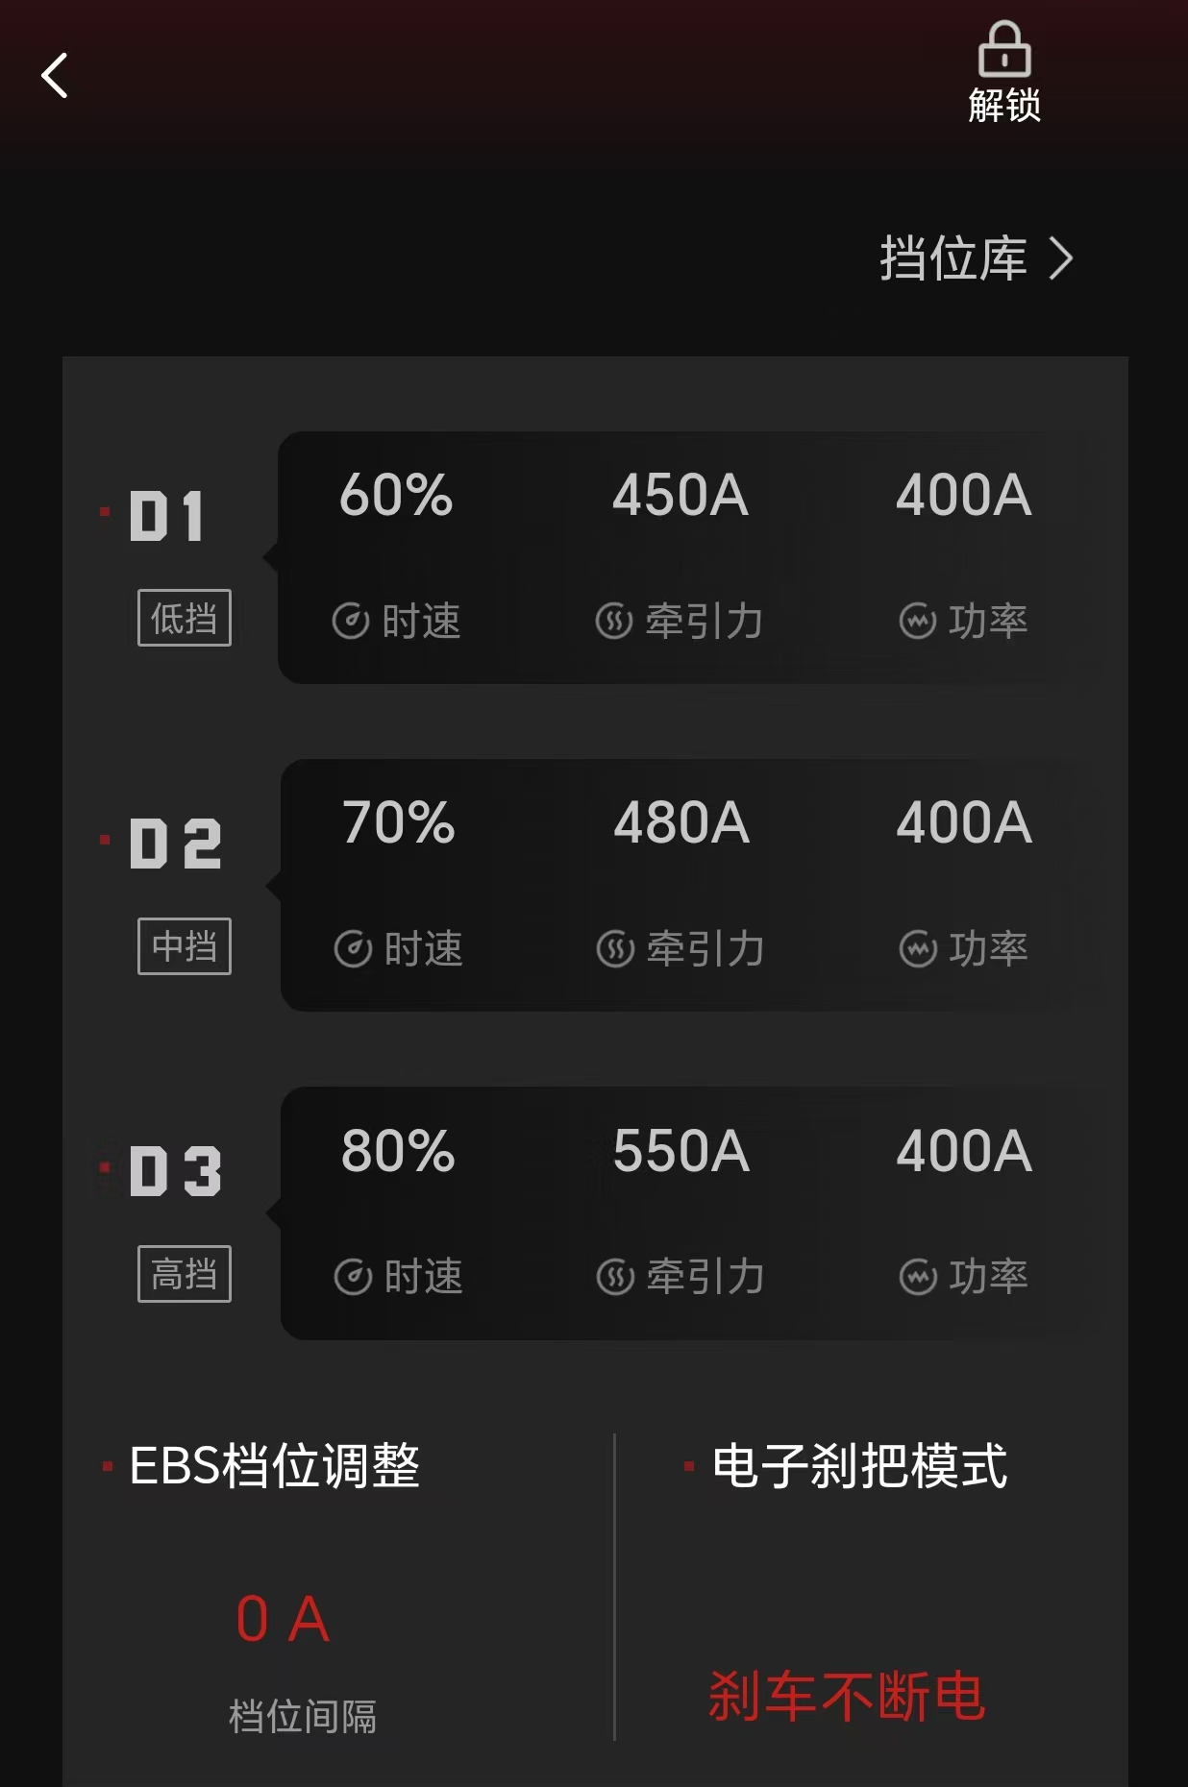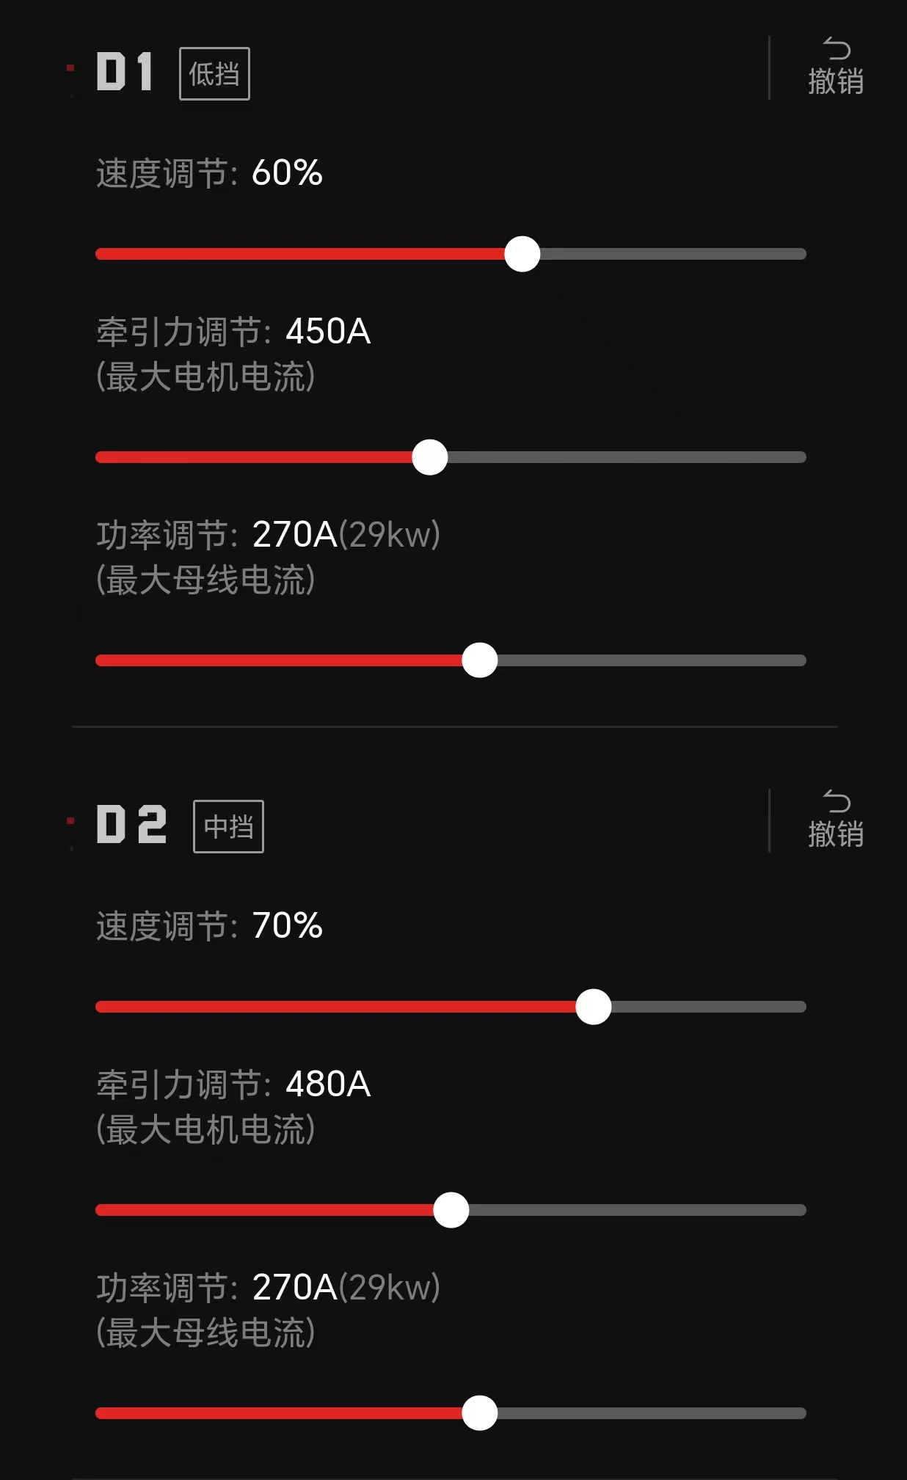
Power Burst (PB): This parameter adjusts the rate at which traction force changes by modifying the throttle travel response. A higher value signifies quicker traction delivery, meaning greater torque can be achieved at the same throttle input. This setting is ideal for steep inclines, sudden starts, or obstacle climbing. Conversely, a lower value results in slower traction delivery, providing smaller torque at the same throttle input, making it suitable for conditions with poor grip.

Hight Speed Power Compensation (HC): This feature compensates for traction at higher speeds, particularly during secondary acceleration. A higher compensation value allows for better traction at elevated speeds, facilitating a higher top speed. However, it may reduce the linearity of speed control in the mid-to-high-speed range, thereby diminishing handling precision.
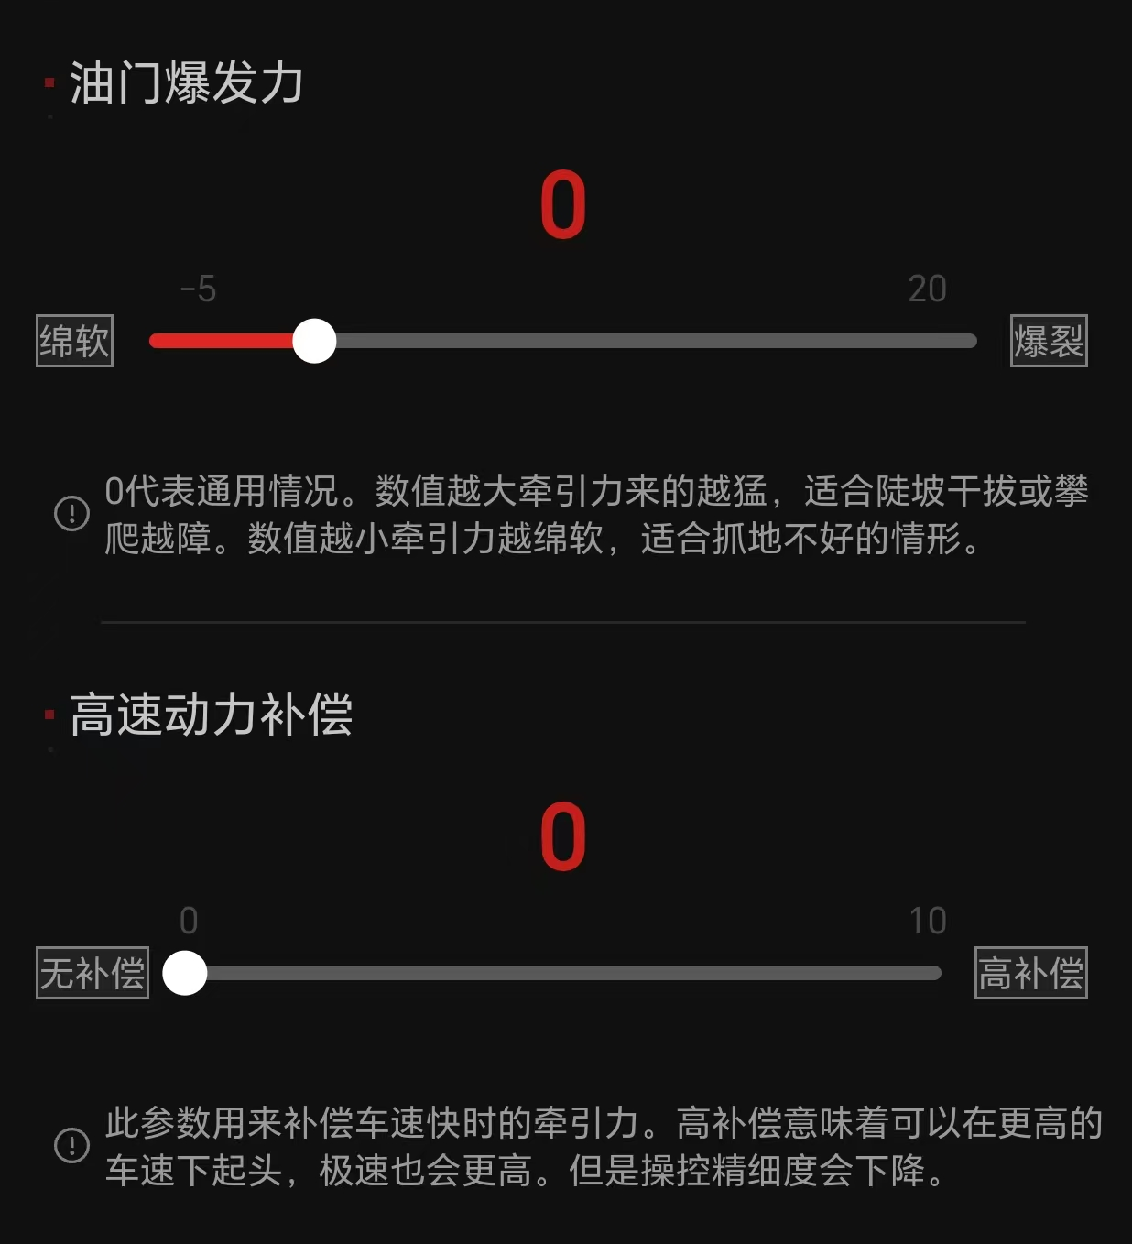
◎Sensory Parameters — Practical Application:

ECO:
Speed: 50% — Traction: 430A — PB: 0 — HC: 0
Features: Moderate power and acceleration, energy-efficient, suitable for daily travel.

Race:
Speed: 70% — Traction: 500A — PB: 0 — HC: 0
Features: Moderate power with high top speed capability, ideal for performance-oriented riding requiring greater speed.

Gasoline-125 :
Speed: 100% — Traction: 350A — PB: 2 — HC: 4
Features: Slower acceleration paired with high top speed, designed for those who prefer the tactile sensation of a gasoline-powered vehicle while seeking exceptional speed.

Crawl:
Speed: 10% — Traction: 300A — PB: -3 — HC: 0
Features: High torque, low-speed creeping mode, ideal for walking the vehicle alongside.

Launch:
Speed: 100% — Traction: 600A — PB: 8 — HC: 6
Features: Maximum power and rapid acceleration, perfect for zero-to-hundred-speed tests or dynamic quick starts.

Strong-ECO：
Speed: 50% — Traction: 550A — PB: 3 — HC: 0
Features: High power and brisk acceleration, with no weak magnetic mode for improved energy efficiency. Perfect for savvy riders’everyday commutes.
Slushy：
Speed: 20% — Traction: 500A — PB: -2 — HC: 0
Features: High torque with low power, offering refined and delicate handling. Suitable for extremely slippery yet non-steep surfaces.

◎Sensory Parameters — Correlation Curve
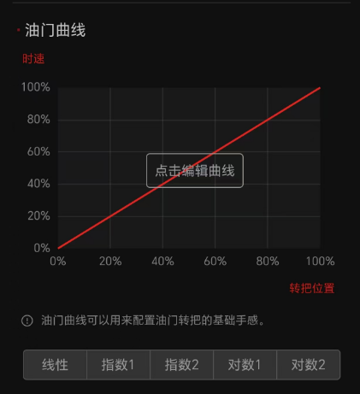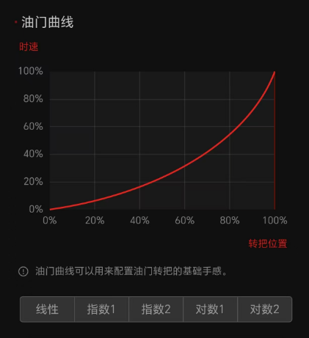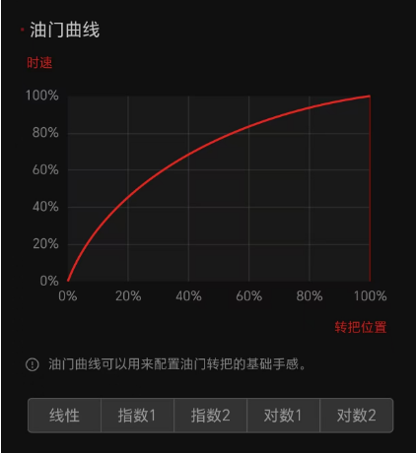
Throttle Curve: Customize or select from pre-existing system curves to configure the basic feel of the throttle grip.

—The default curve is linear, where the relationship between throttle opening and speed is linear. This means that as the throttle is turned, the speed changes uniformly, suitable for most riding conditions. Users can choose exponential or logarithmic curves based on their actual experience.

Regen Brake Curve: Edit custom curves or select the system's default linear curve to configure the basic feel of the regen brake (thumb brake). The regen brake curve utilizes motor drag to enhance the braking force of the disc brake, allowing for a perfectly balanced tactile experience by aligning with the disc brake dynamics.
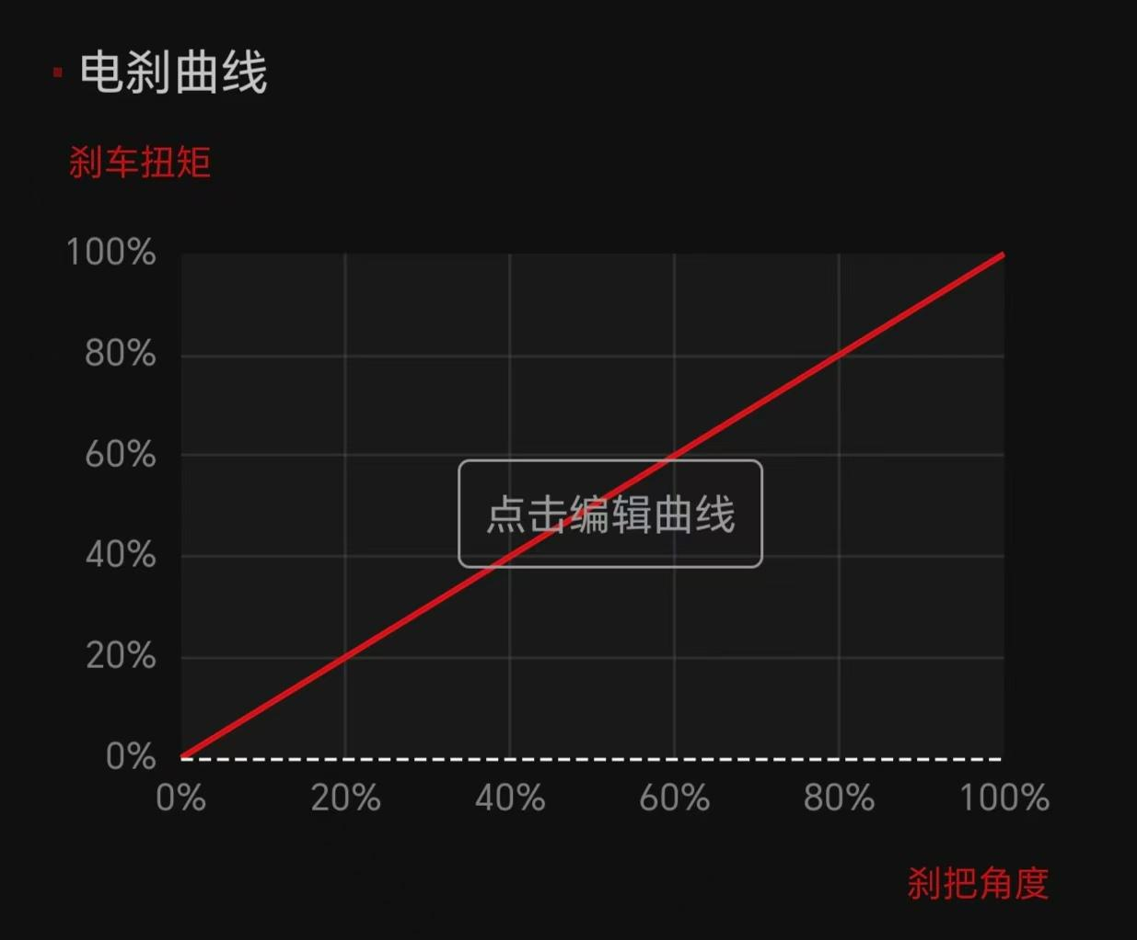
◎Parameter Overview — Additional Parameters

Power Adjustment: Configures the maximum bus current, which affects the top speed. This adjustment has minimal impact on the throttle feel and is not recommended for modification.

EBS Gear Adjustment: Sets the intervals for the Energy Braking System (EBS) during kinetic energy recovery. The maximum interval is 50.

Custom Maximum Throttle Voltage: Specifies the voltage recognized as full throttle. This value should be slightly lower than the actual full-throttle voltage.

Custom Minimum Throttle Voltage: Defines the voltage recognized as idle throttle. This value should be slightly higher than the actual idle-throttle voltage. A lower value reduces the throttle's initial gap.

Disable Speed: Determines the maximum speed when switched to reverse gear (R) or parking mode (P).

Motor Stalling Delay: Specifies how long the motor can remain in a stalled state, with the standard setting typically being 2.5 seconds.
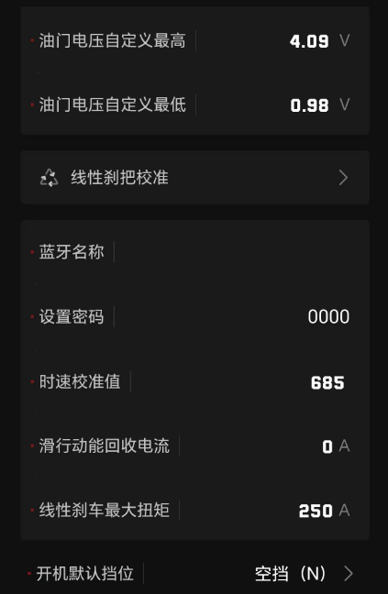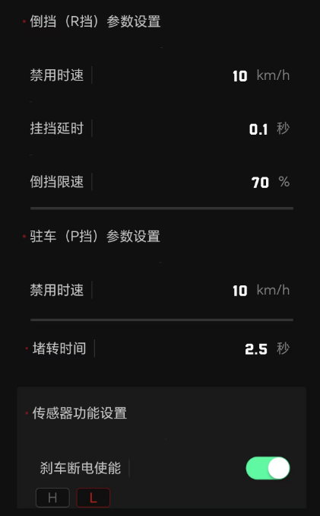
3. Real-Time Status

Monitor all maximum and minimum values during the riding process.
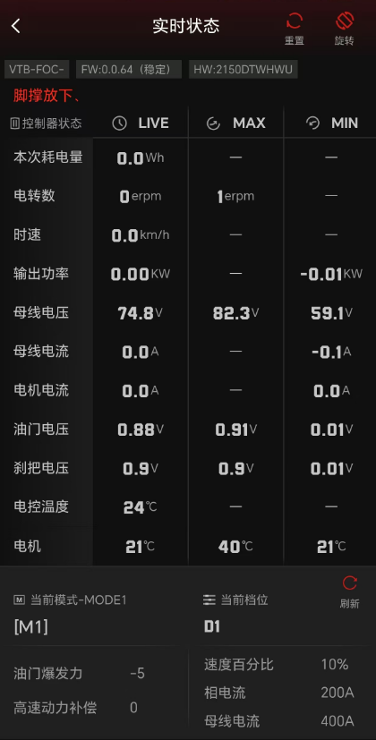

4. Firmware Upgrade
Enjoy seamless system updates through continuous OTA service. Additionally, Vantusi offers select users the opportunity to participate in beta testing for new firmware. Interested users may contact the official team to secure a spot and experience the latest features.

Note: During the firmware upgrade process, ensure your phone remains close to the dashboard or controller and avoid moving the device. Follow the on-screen instructions and wait for the upgrade to complete. Controller updates typically take about 5 minutes when upgrading to the latest version. Dashboard updates require 1–3 minutes under normal circumstances; however, updating across multiple versions in a single session can take 1–2 hours. Please allocate adequate time for the upgrade accordingly.
